
FATIMA JINNAH WOMEN UNIVERSITY
RAWALPINDI
Department of Software Engineering

Assignment no 2

SUBJECT: CLOUD COMPUTING
Name: Saira Ejaz
Reg No: 2023-BSE-057
Section: 5-B
Date: 30-Dec-2025

Executive Summary

Overview:
This assignment demonstrates the deployment of a multi-tier web infrastructure on AWS using Terraform. It involves creating an automated, scalable, and secure environment consisting of a VPC, public subnet, internet gateway, route tables, security groups, and EC2 instances for web and Nginx servers. The project highlights infrastructure-as-code principles by modularizing networking, security, and webserver components. Key tasks include configuring Nginx as a load balancer, deploying Apache web servers, testing load balancing, caching, high availability, and implementing proper security measures. The assignment showcases practical skills in cloud provisioning, automation, and monitoring while ensuring reliable and efficient web service delivery.
2. Architecture Design
Architecture Diagram:
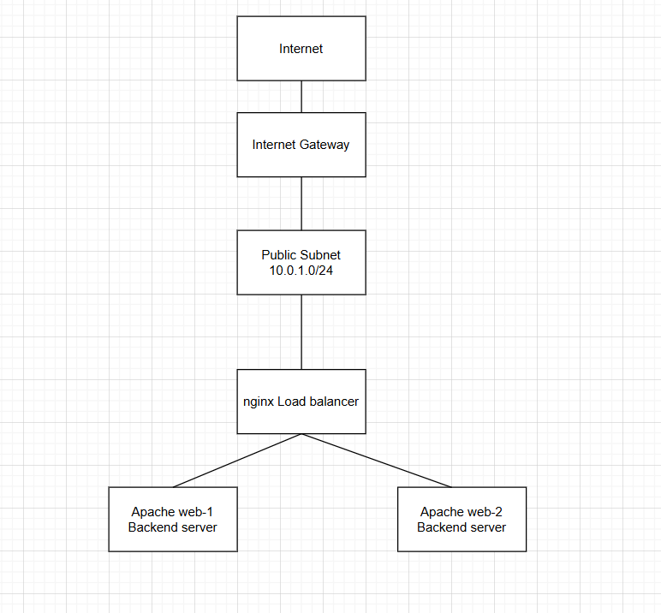
Part 1: Infrastructure Setup (25 marks)
1.1 Project Structure (5 marks)
Create a well-organized Terraform project with the following structure:
Tasks:
- Create all necessary files and directories
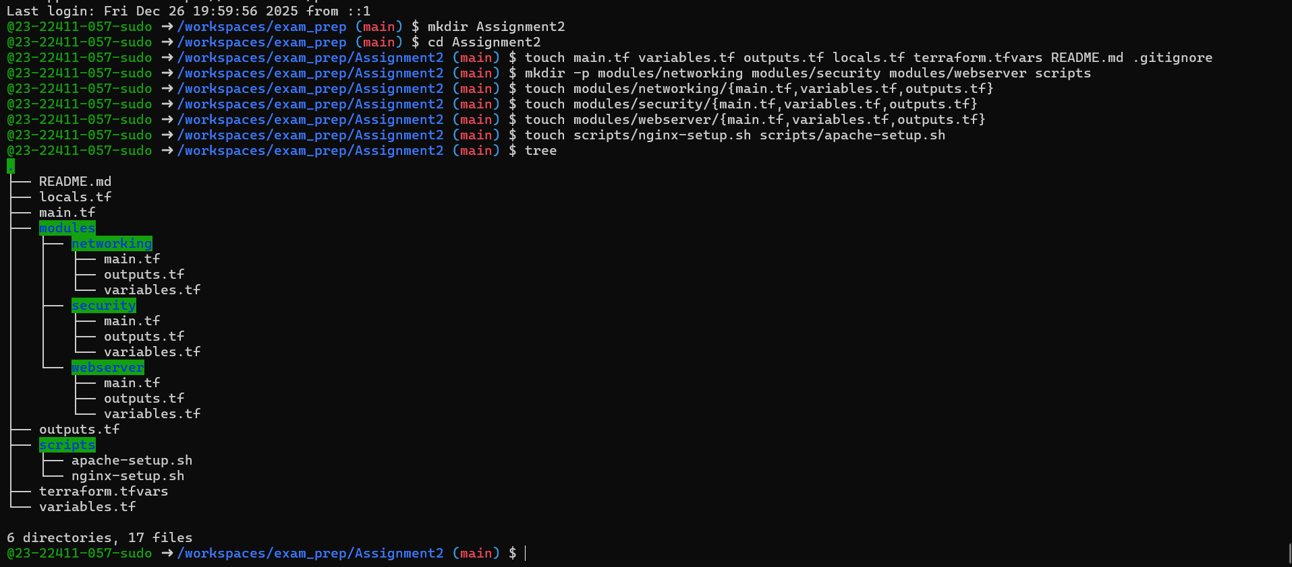
- Implement proper .gitignore to exclude sensitive files
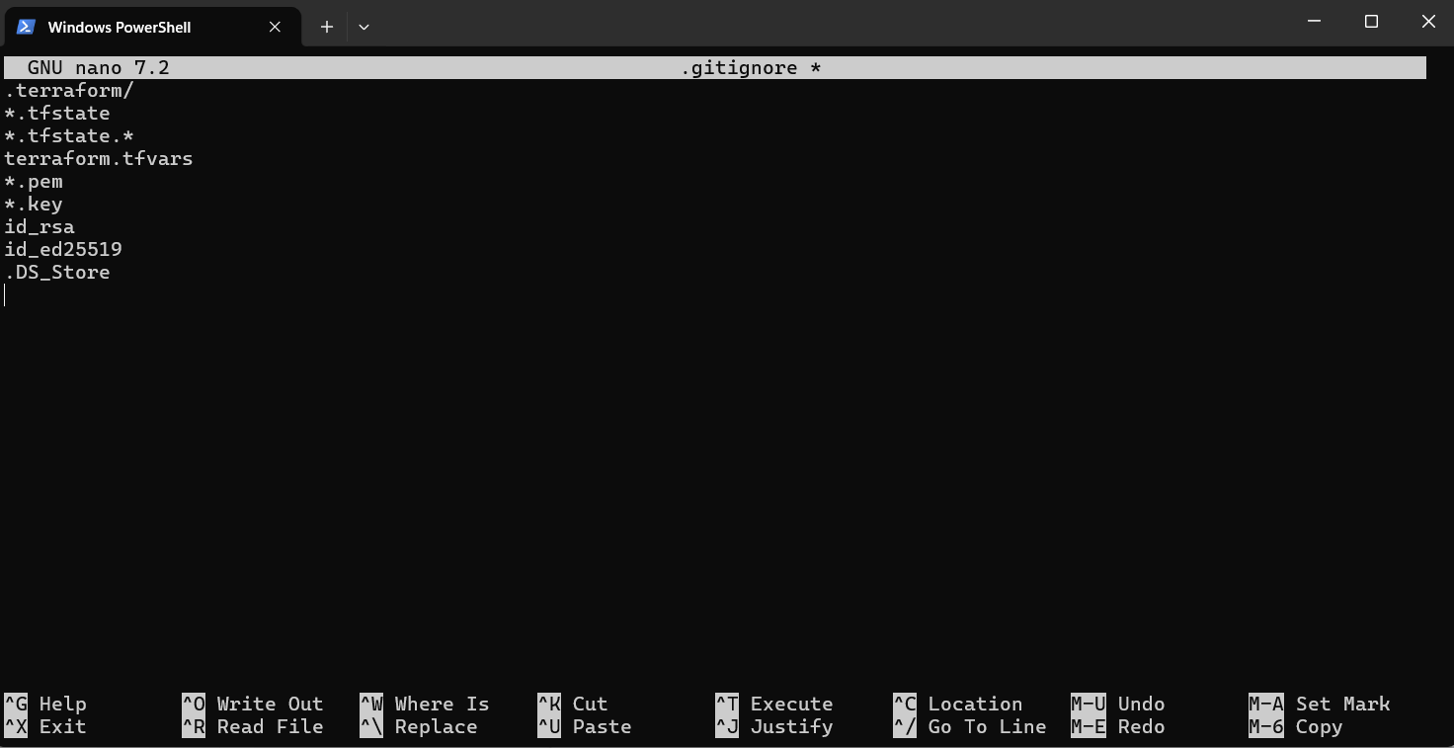
- Document the project structure in README.md
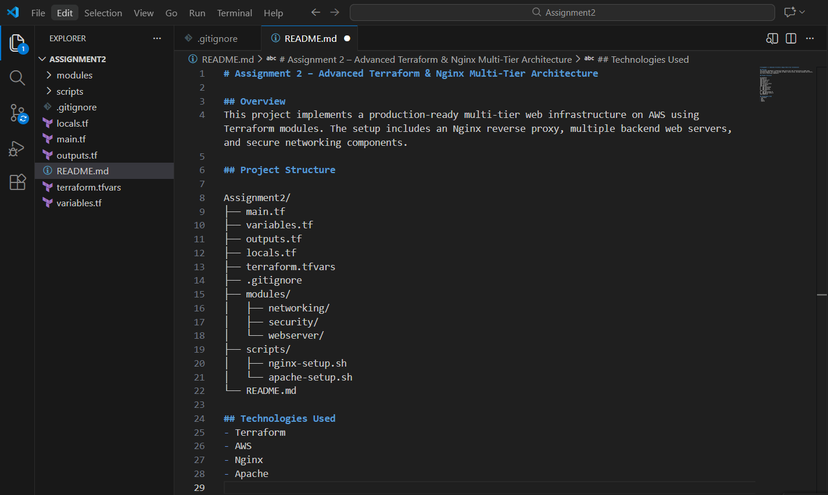

1.2 Variable Configuration (5 marks)
Define all required variables in variables.tf:
Required Variables:
- vpc_cidr_block (string)
- subnet_cidr_block (string)
- availability_zone (string)
- env_prefix (string)
- instance_type (string)
- public_key (string)
- private_key (string)
- backend_servers (list of objects with name and script_path)
Tasks:
- Add validation rules for CIDR blocks
- Add descriptions for all variables
- Set appropriate defaults where applicable
- Populate terraform.tfvars with your values
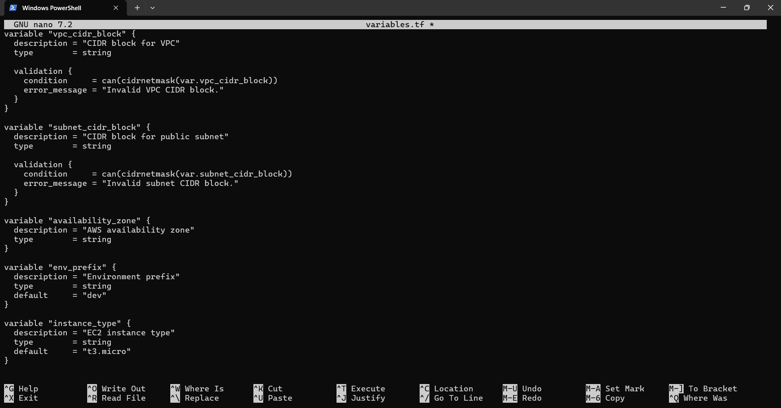
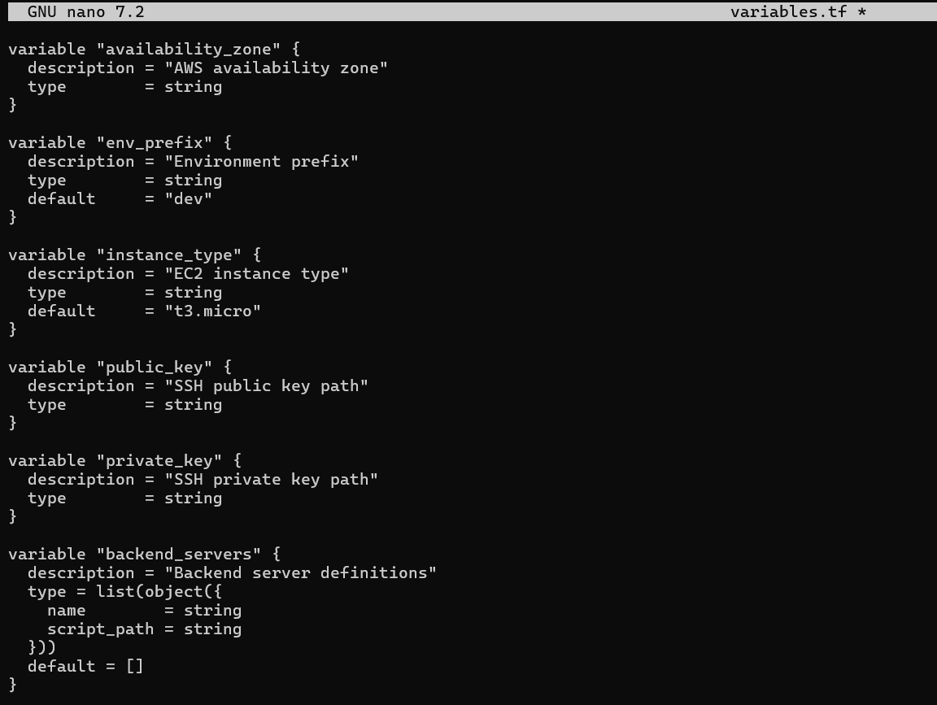
- All required variables are declared with proper data types.
- Descriptions are added to improve readability.
- CIDR blocks are validated to ensure correct network configuration.
- Default values are set where appropriate.
- Sensitive values like private keys are marked as sensitive.
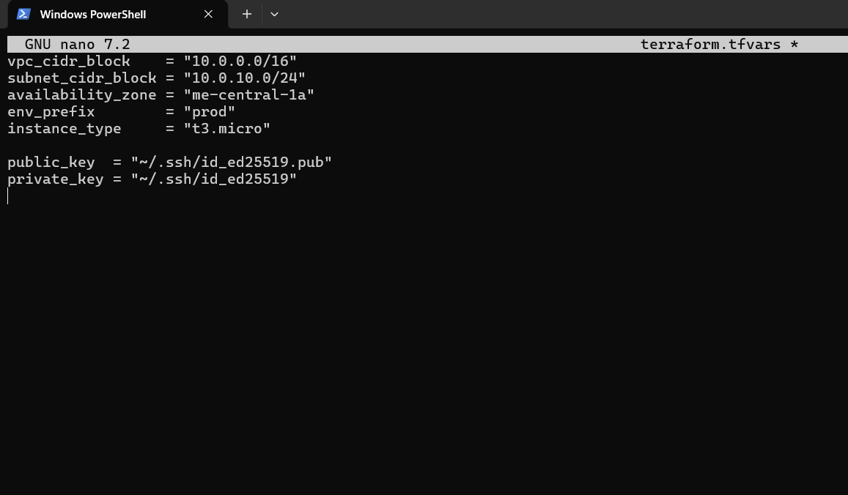
• terraform.tfvars contains environment-specific values.
• Backend servers are defined as a list of objects.
• This file is excluded from GitHub using .gitignore to protect sensitive data.
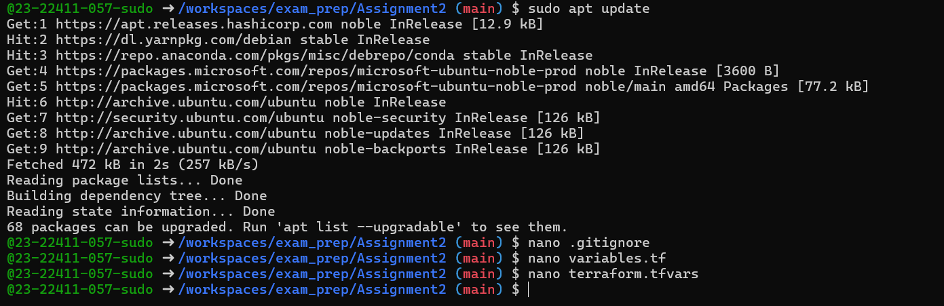

1.3 Networking Module (5 marks)
Create a networking module that provisions:
- VPC with specified CIDR block
- Subnet with public IP assignment enabled
- Internet Gateway
- Route table with default route to IGW
- Associate route table with subnet
Module Location: modules/networking/
Required Outputs:
- vpc_id
- subnet_id
- igw_id
- route_table_id
Tasks:
- Create VPC resource
- Create subnet with map_public_ip_on_launch = true
- Create and attach Internet Gateway
- Configure routing table
- Add proper tags to all resources using env_prefix
Answer:
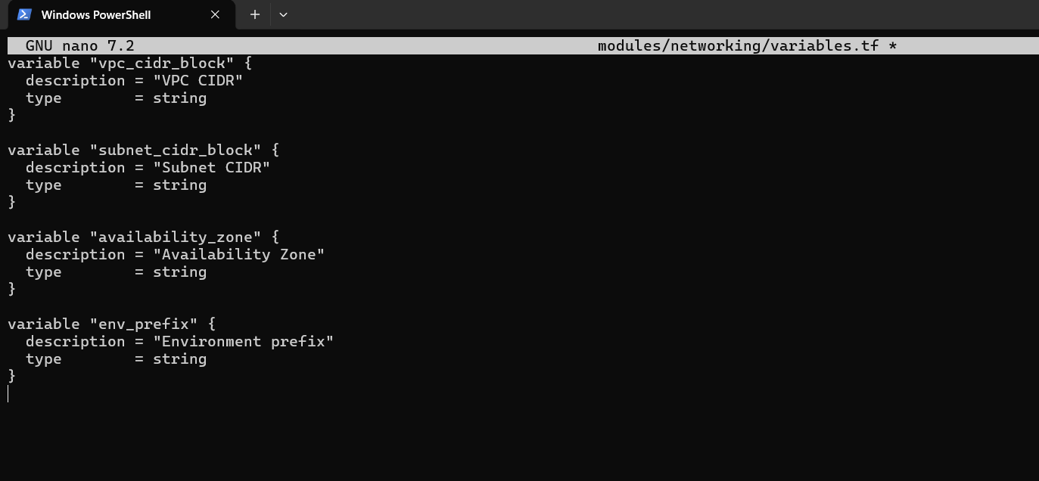
main.tf
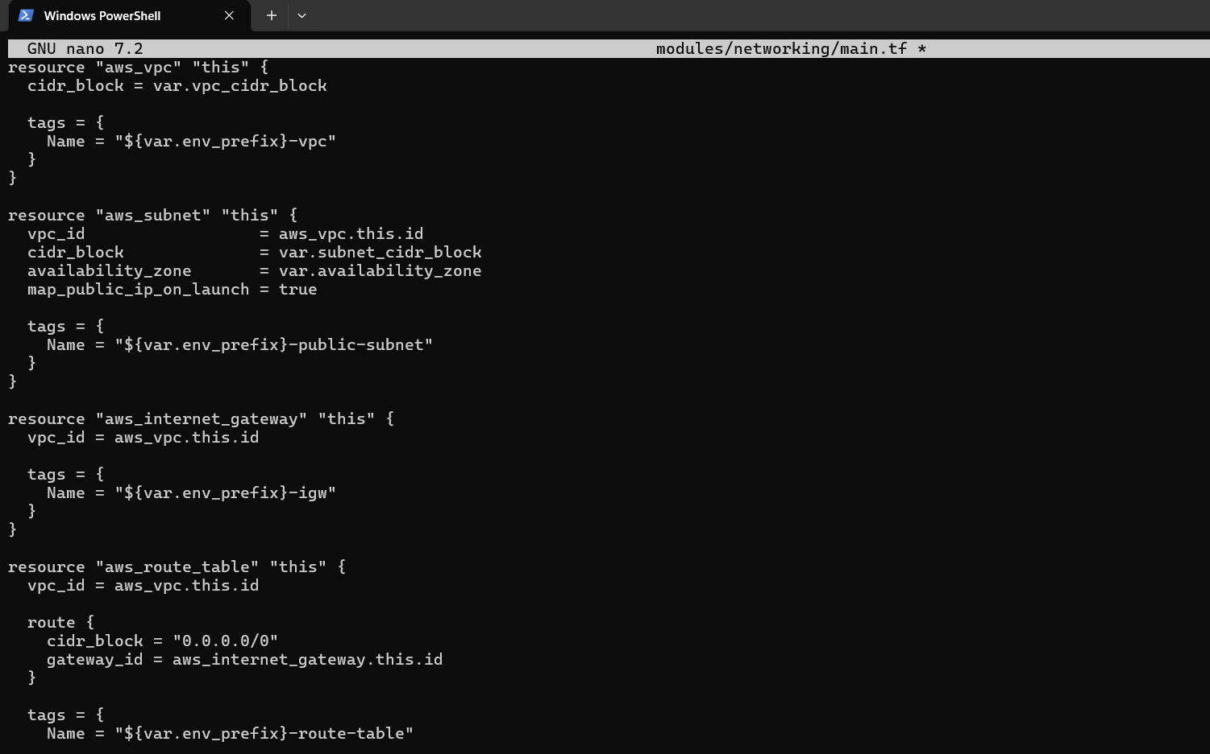
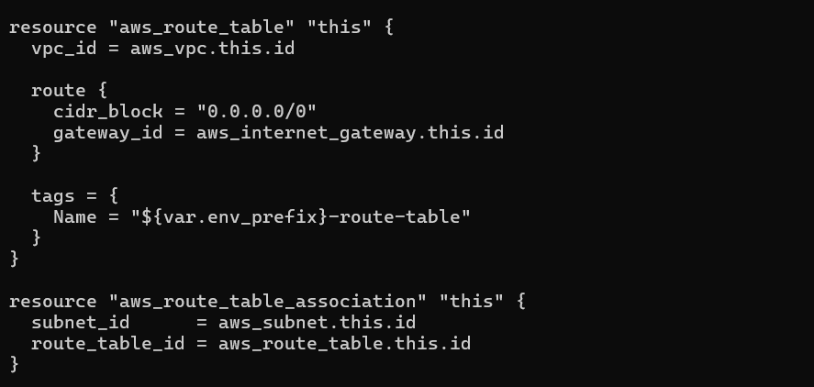
Output.tf
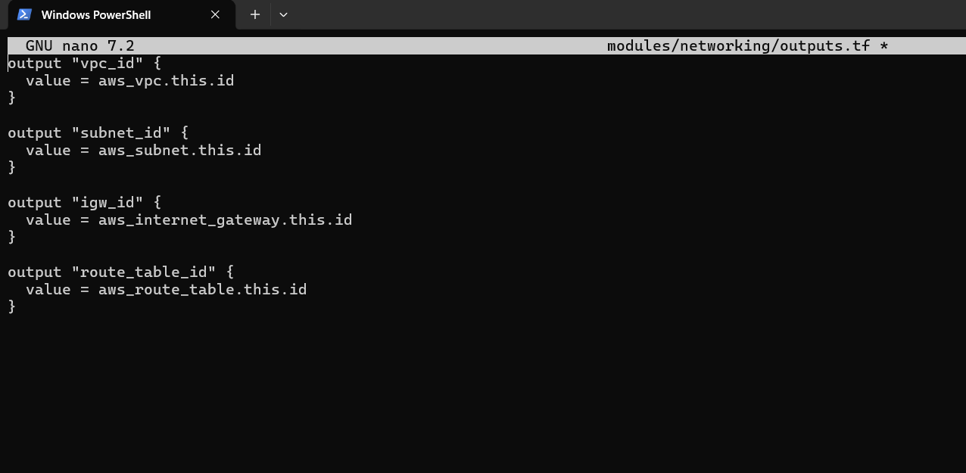
1.4 Security Module (5 marks)
Create a security module that provisions:
Two Security Groups:
Nginx Security Group (for reverse proxy/load balancer):
Ingress: Port 22 (SSH) from your IP only
Ingress: Port 80 (HTTP) from anywhere (0.0.0.0/0)
Ingress: Port 443 (HTTPS) from anywhere (0.0.0.0/0)
Egress: All traffic
Backend Security Group (for web servers):
Ingress: Port 22 (SSH) from your IP only
Ingress: Port 80 (HTTP) from Nginx security group only
Egress: All traffic
Module Location: modules/security/
Required Variables:
vpc_id
env_prefix
my_ip
Required Outputs:
nginx_sg_id
backend_sg_id
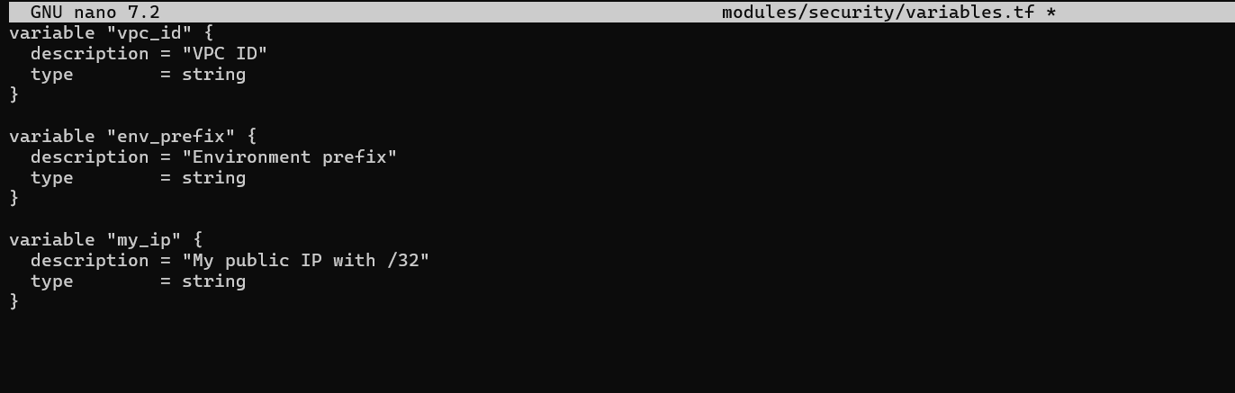
nano modules/security/main.tf
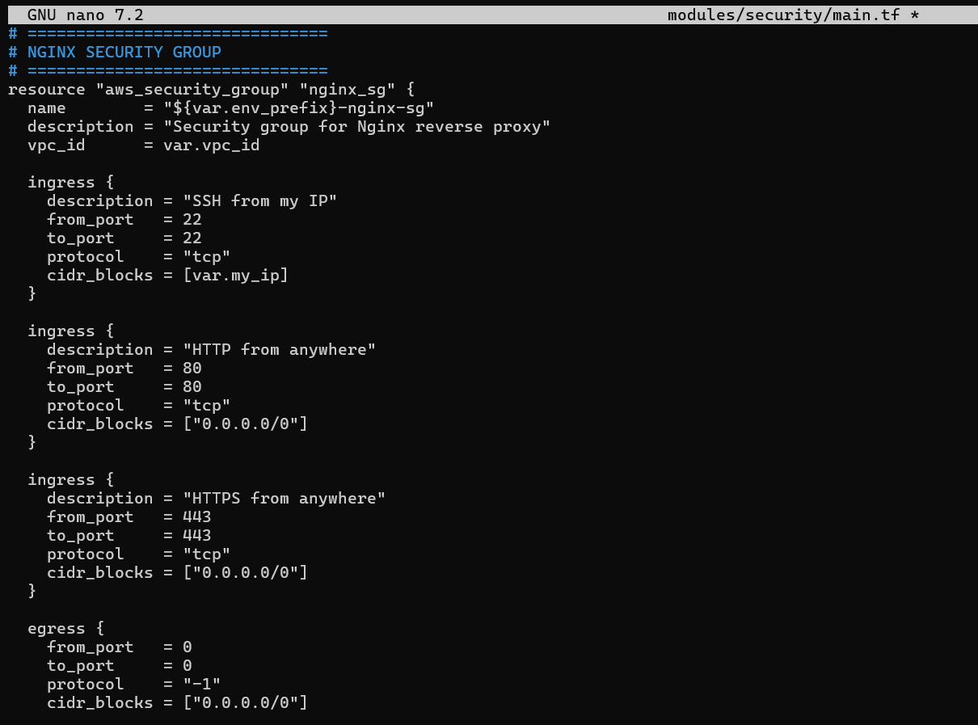
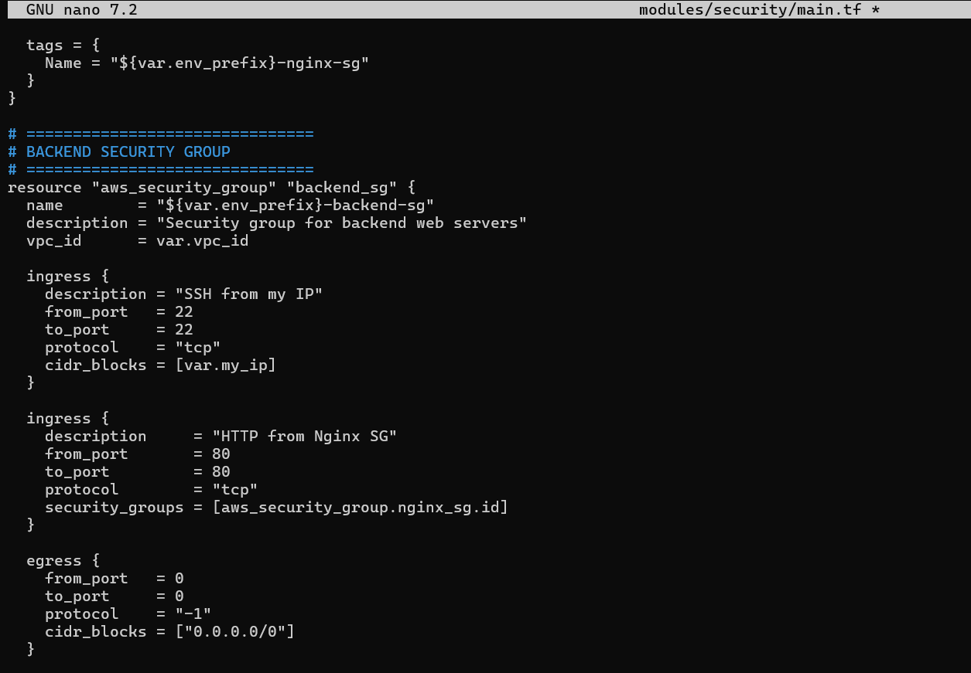
nano modules/security/outputs.tf
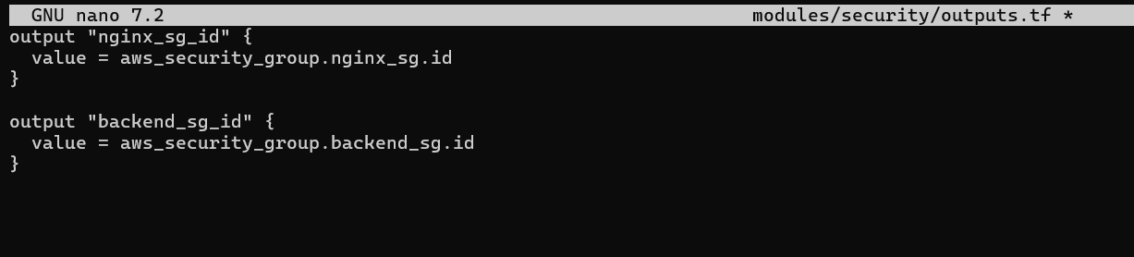
Root main: nano main.tf
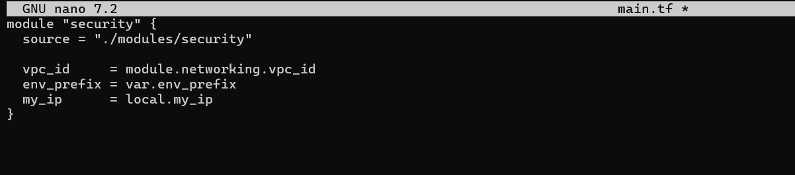
1.5 Locals Configuration (5 marks)
Create locals.tf with:
Dynamic IP detection for my_ip
Resource naming conventions
Common tags
Backend server configurations
Tasks:
Implement dynamic IP detection
Define common tags
Define backend server list
Add any other reusable local values
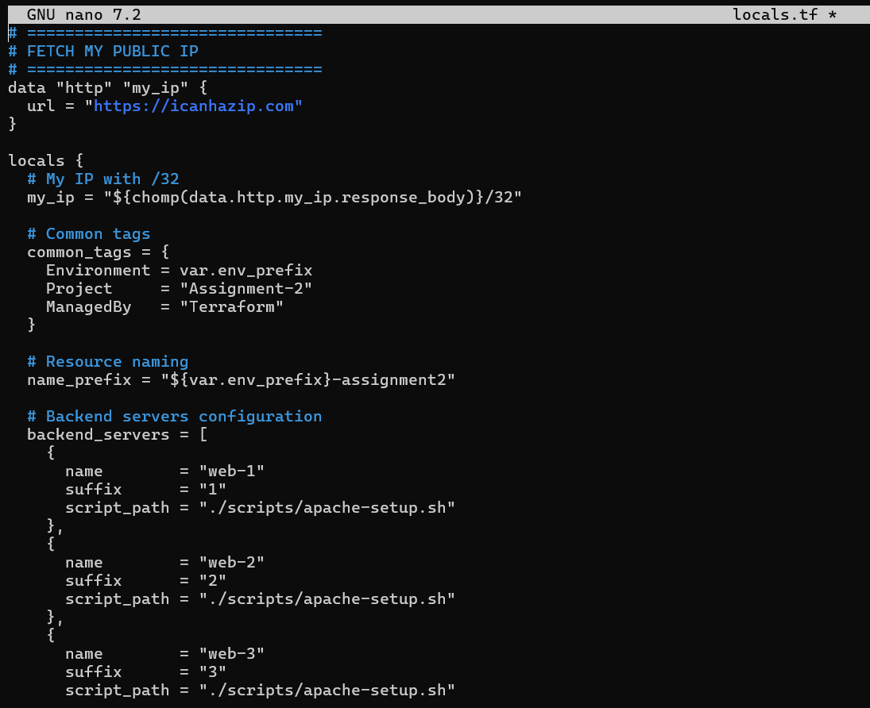
Part 2: Webserver Module (15 marks)
2.1 Module Design (10 marks)
Resources to Create:
- AWS Key Pair (unique per instance using suffix)
- EC2 Instance with:
  - Specified AMI (Amazon Linux 2023)
  - Public IP enabled
  - User data from script file
  - Proper tags
Tasks:
- Create variables. tf with all required variables
- Create main.tf with key pair and instance resources
- Create outputs.tf with all required outputs
- Ensure module is reusable for both Nginx and backend servers
- nano modules/webserver/variables.tf
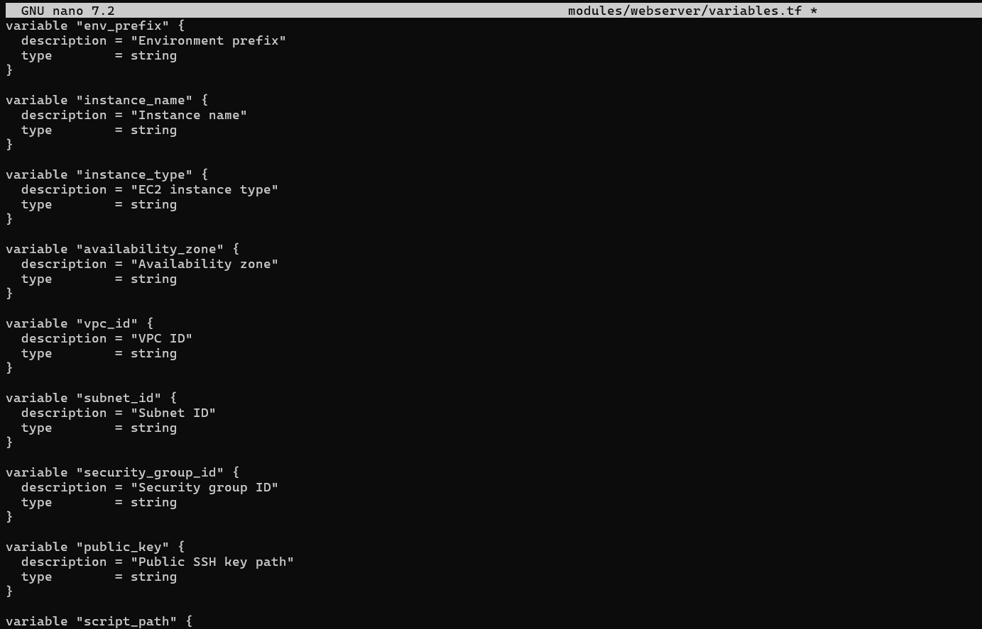
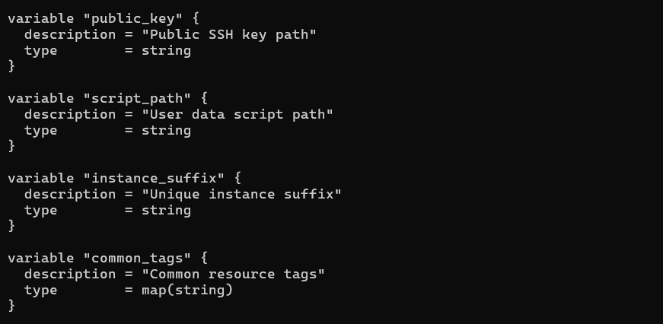
- nano modules/webserver/main.tf
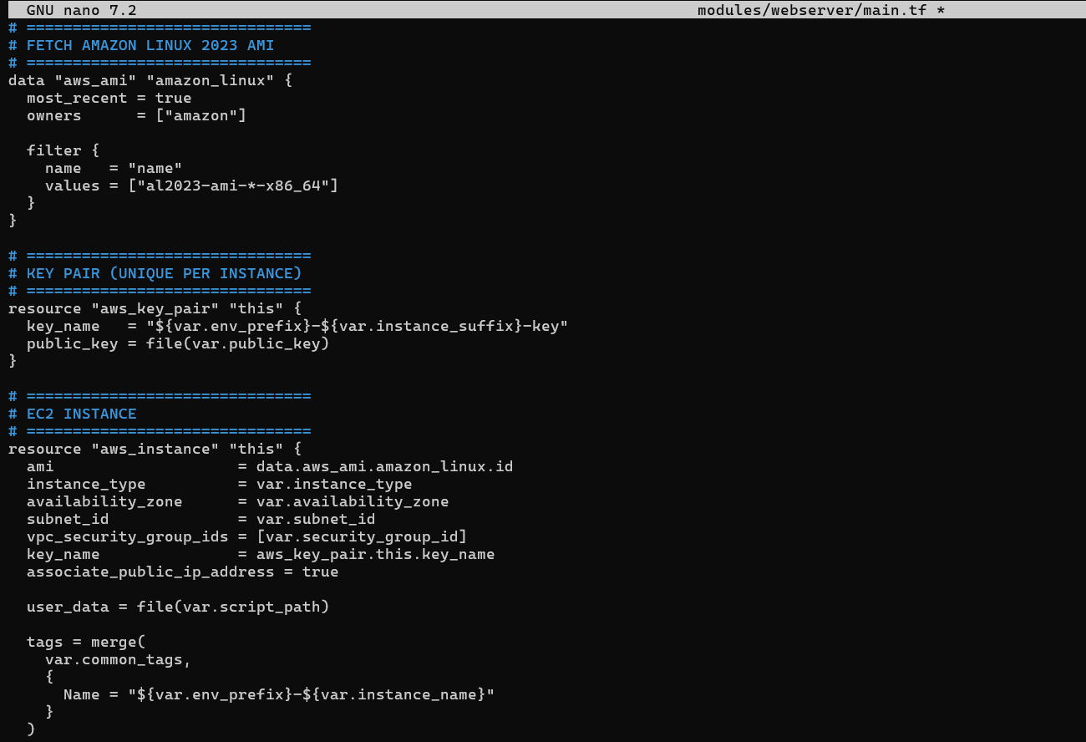
- nano modules/webserver/outputs.tf
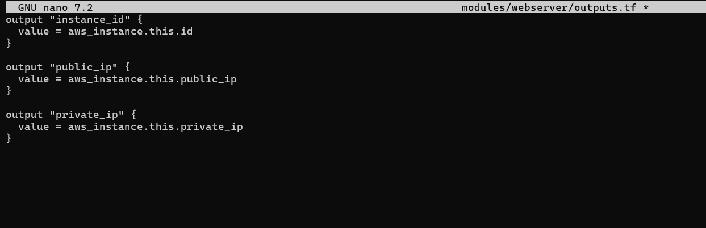
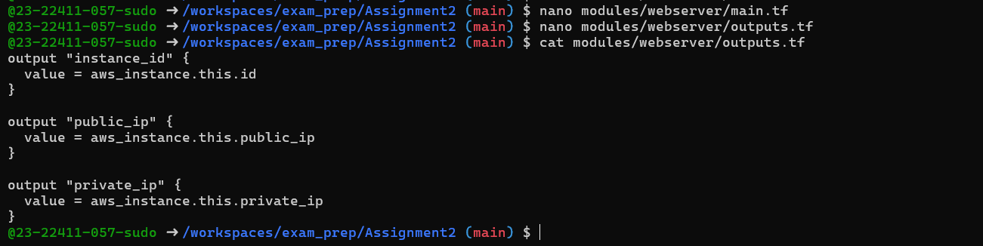

2.2 Module Usage (5 marks)
In root main.tf, instantiate the webserver module for:
- One Nginx server (using nginx-setup.sh)
- Three backend servers (web-1, web-2, web-3 using apache-setup.sh)
Tasks:
- Create Nginx server module instance
- Create backend server module instances using for_each
- Ensure proper security group assignment
- Pass all required variables
- nano main.tf
Add nginx server module and backend server
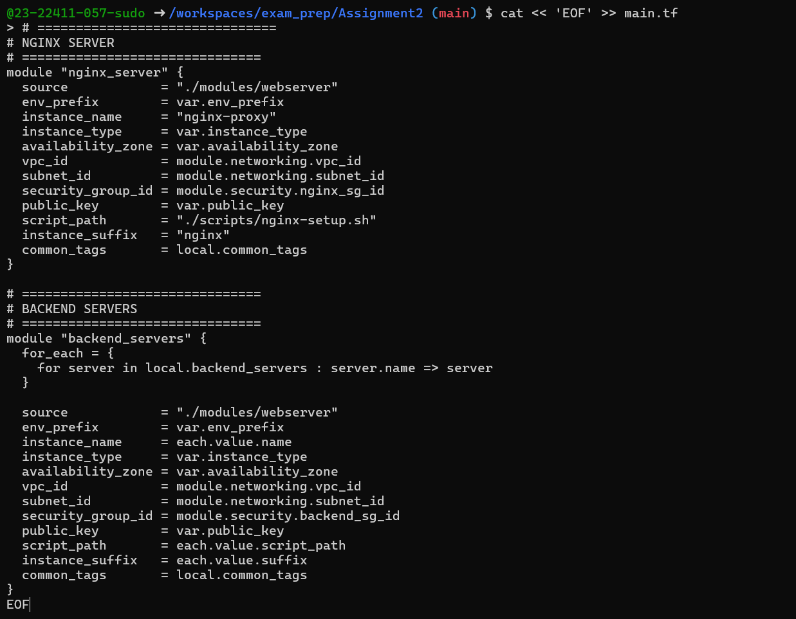
Part 3: Server Configuration Scripts (20 marks)
3.1 Apache Backend Server Script (10 marks)
Tasks:
- Create the script with all required features
- Ensure it uses IMDSv2 for metadata
- Create visually appealing HTML output
- Make script executable
- Test script independently
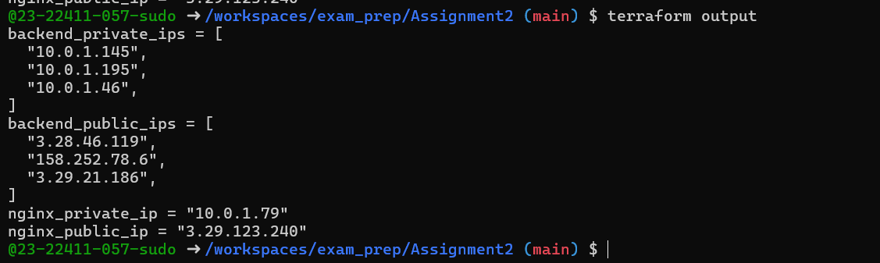
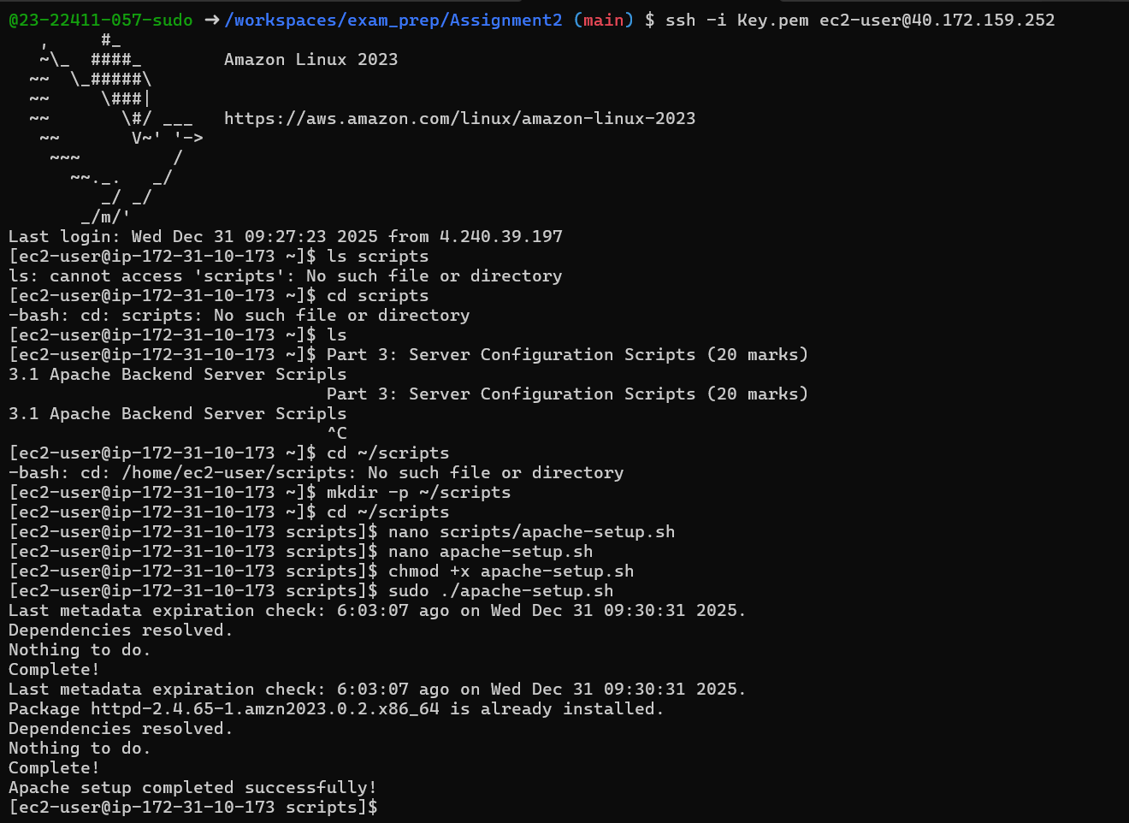
Deliverables:
Screenshot: assignment_part3_apache_script.png
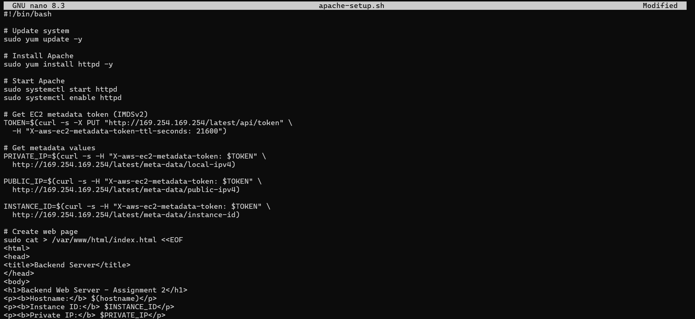
Screenshot: assignment_part3_backend_webpage.png (browser showing backend server page)
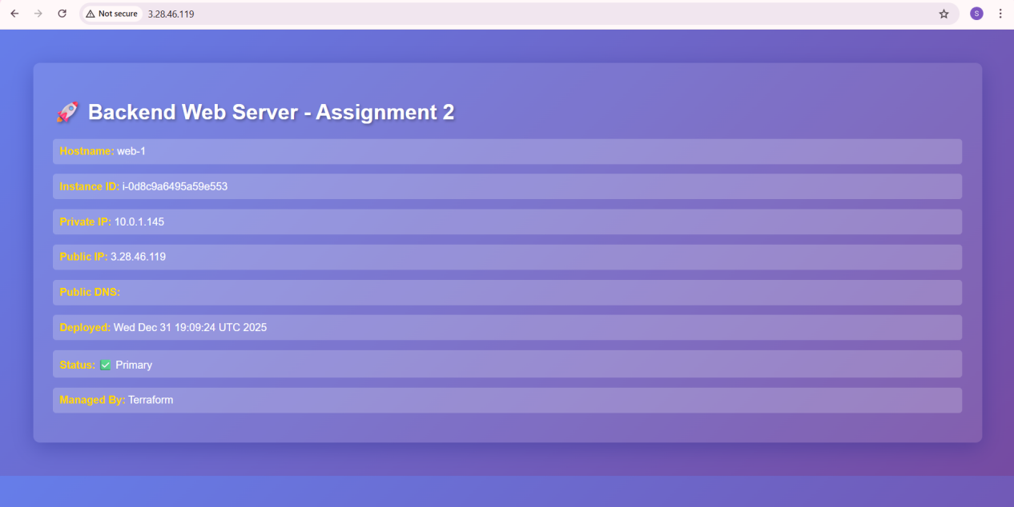
3.2 Nginx Server Setup Script (10 marks)
Create scripts/nginx-setup.sh that:
Deliverables:
Screenshot: assignment_part3_nginx_script.png
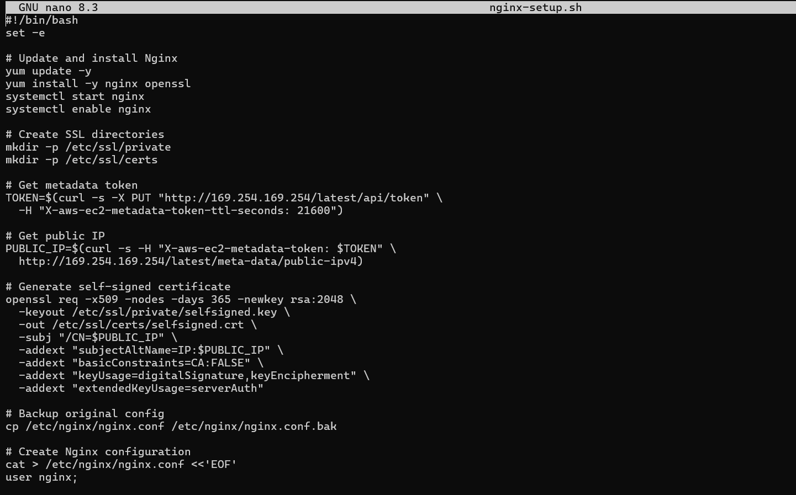

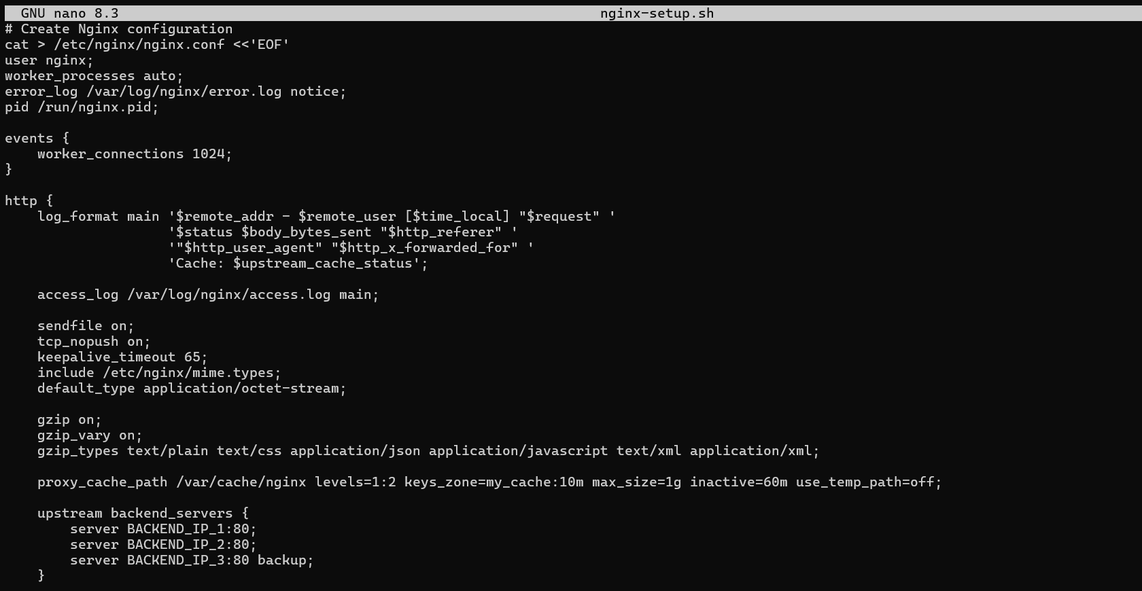
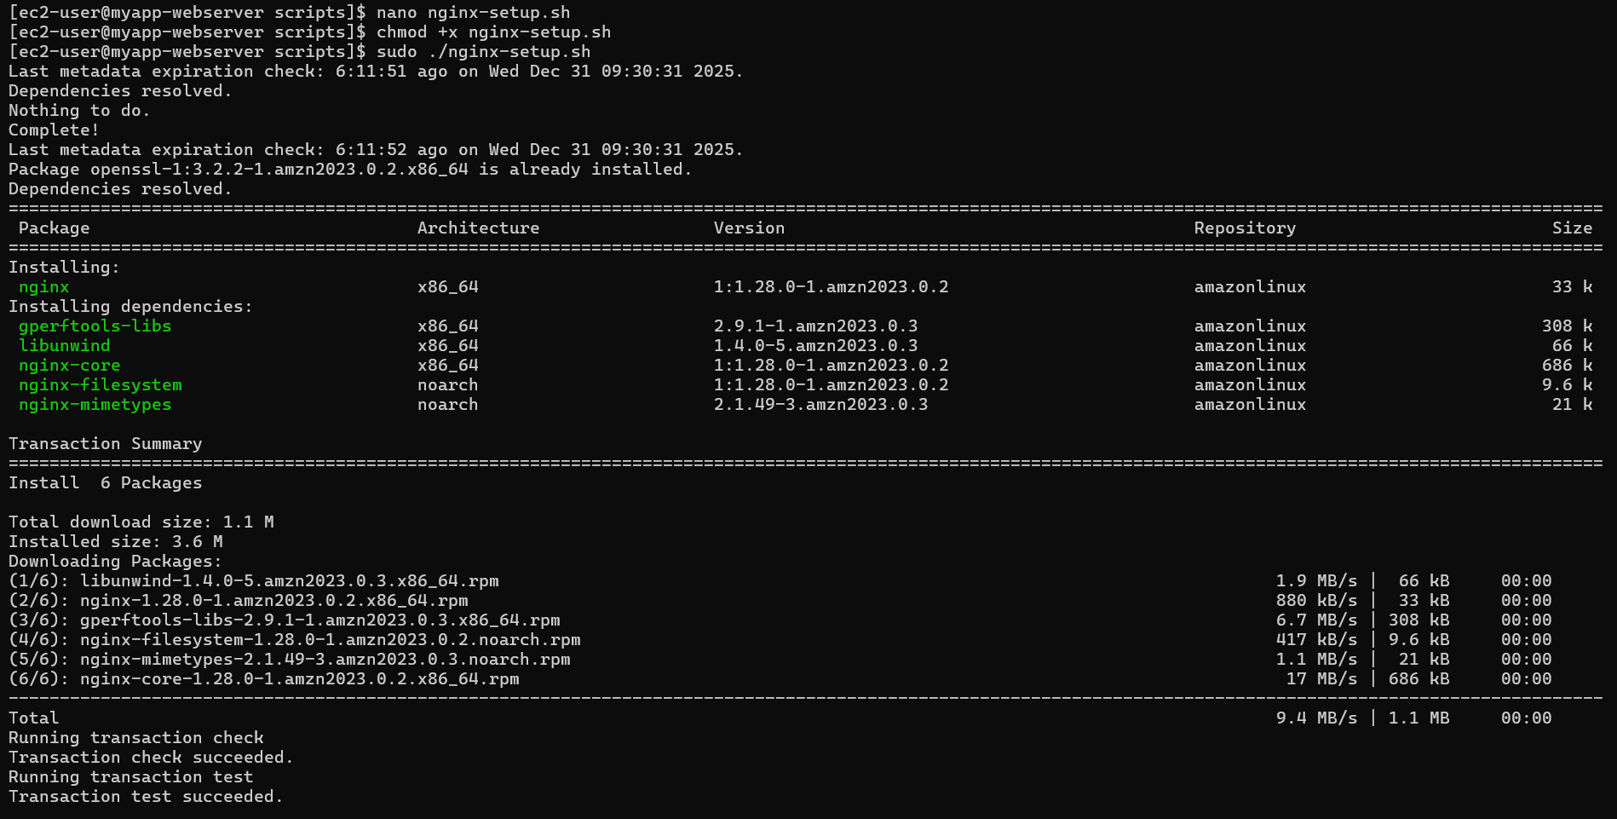
Screenshot: assignment_part3_nginx_default_page.png (before backend configuration)
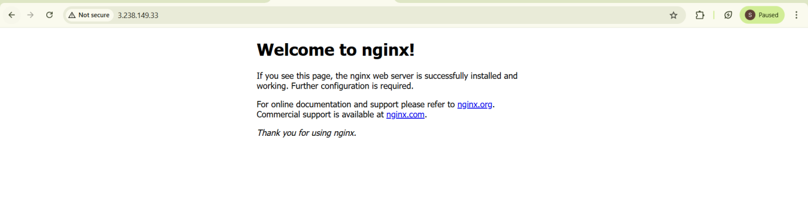

Part 4: Infrastructure Deployment (15 marks)
4.1 Initial Deployment (5 marks)
Deploy the infrastructure using Terraform.
Tasks:
Generate SSH key pair if not exists
Initialize Terraform (terraform init)
Validate configuration (terraform validate)
Plan deployment (terraform plan)
Apply configuration (terraform apply -auto-approve)
- assignment_part4_ssh_keygen.png
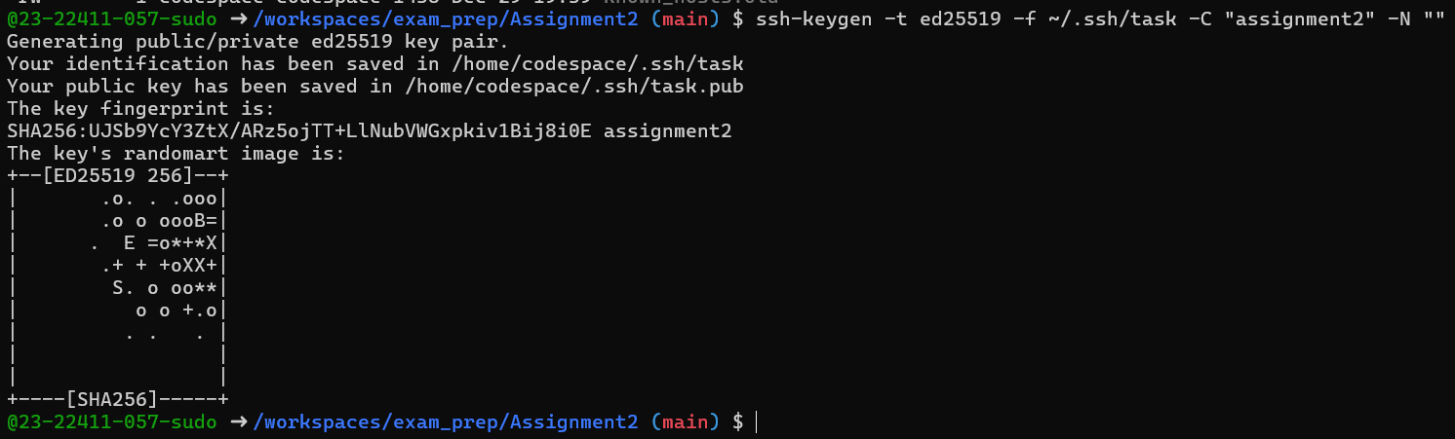
- assignment_part4_terraform_init.png
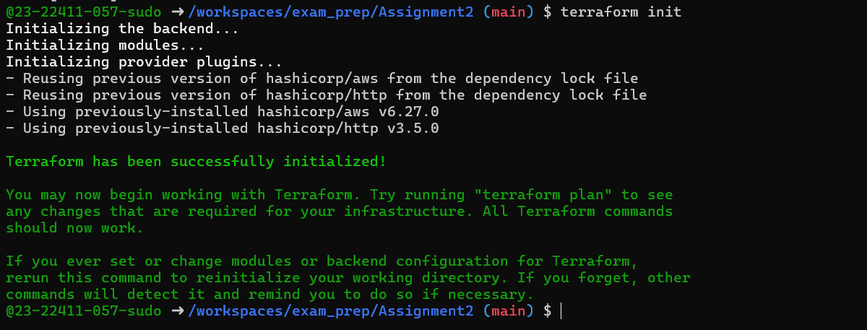
- assignment_part4_terraform_validate.png
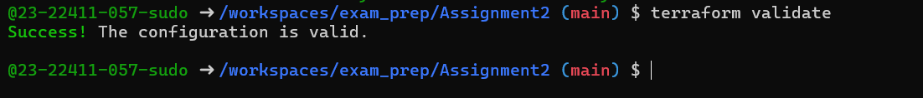
- assignment_part4_terraform_plan.png
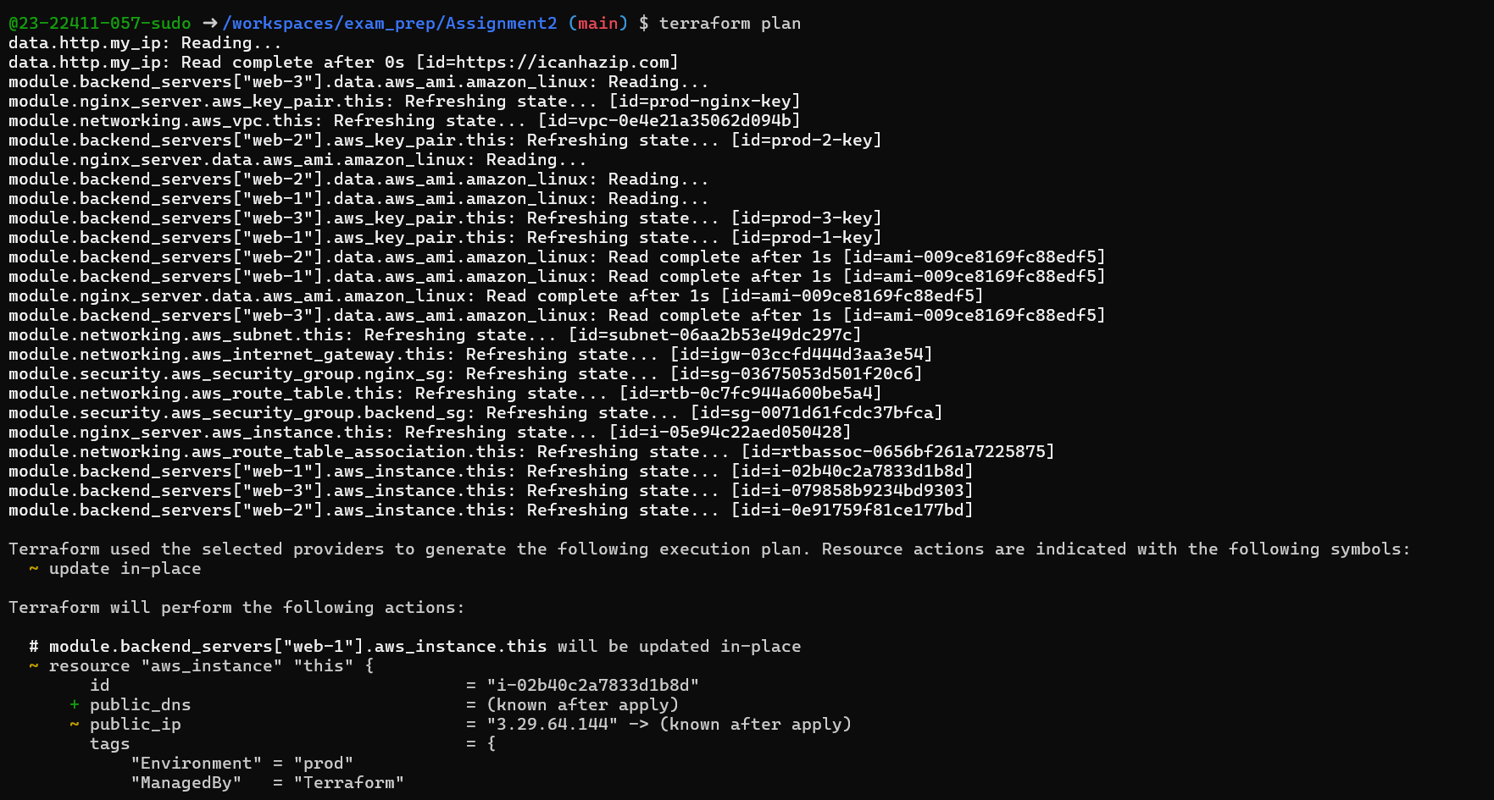
- assignment_part4_terraform_apply.png (showing all 4 instances created)
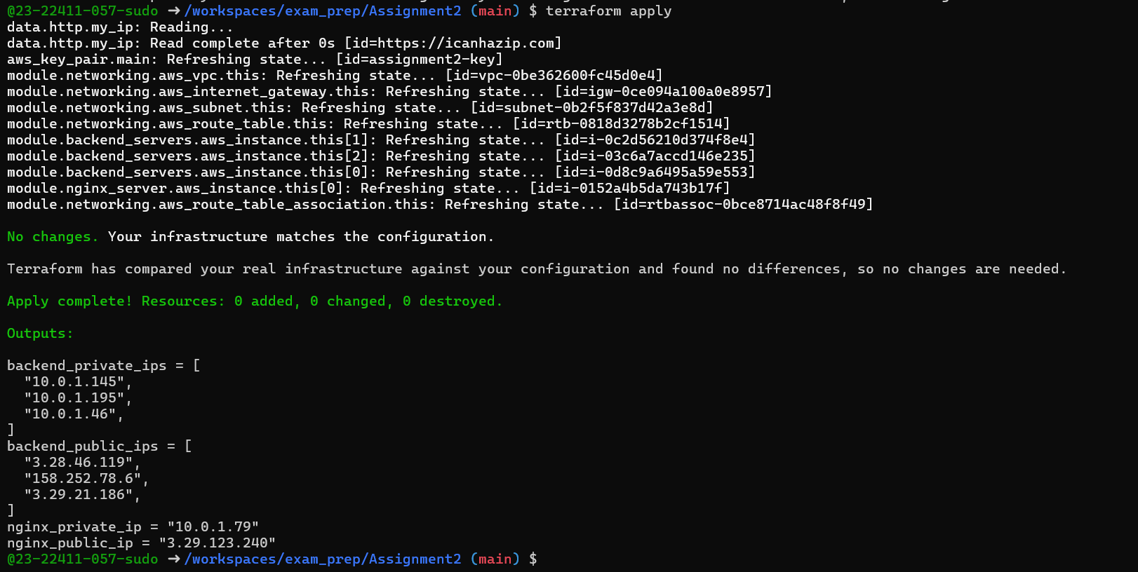
4.2 Output Configuration (5 marks)
1. Screenshot: assignment_part4_terraform_output.png
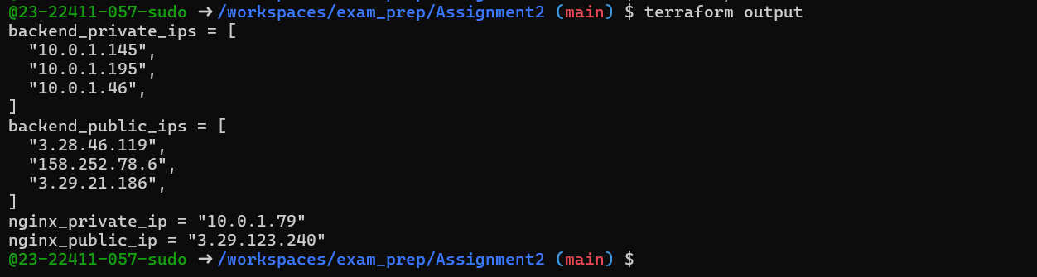
2. Screenshot: assignment_part4_outputs_json.png
4.3 AWS Console Verification (5 marks)
Verify all resources in AWS Console.
- assignment_part4_aws_vpc. Png
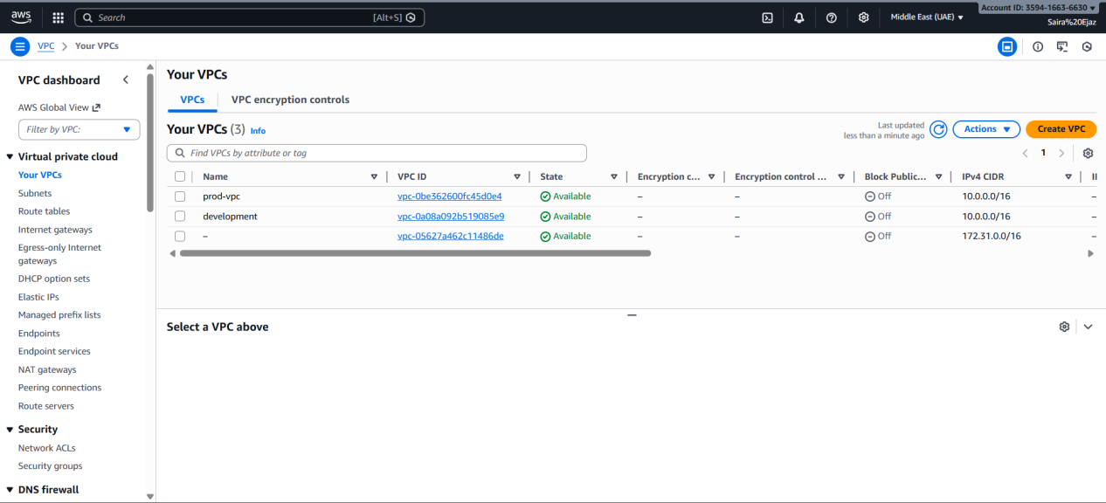
- assignment_part4_aws_subnet.png
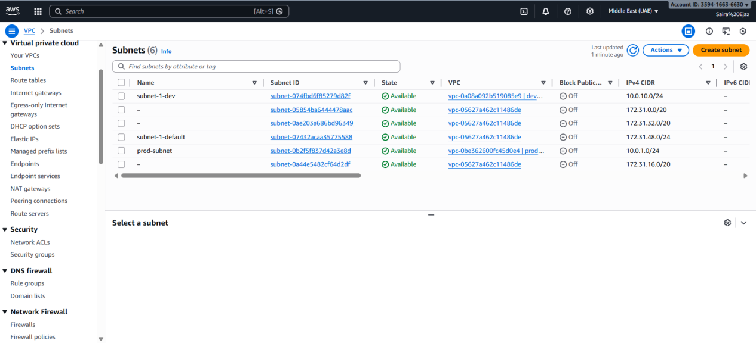
- assignment_part4_aws_security_groups.png
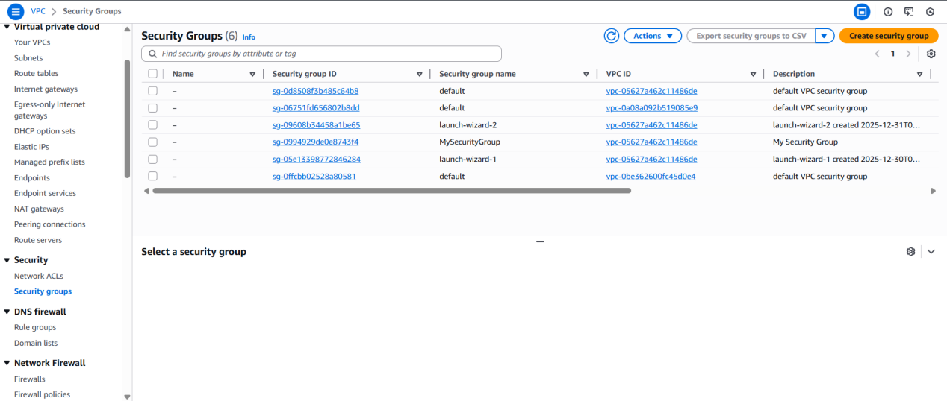
- assignment_part4_aws_instances.png
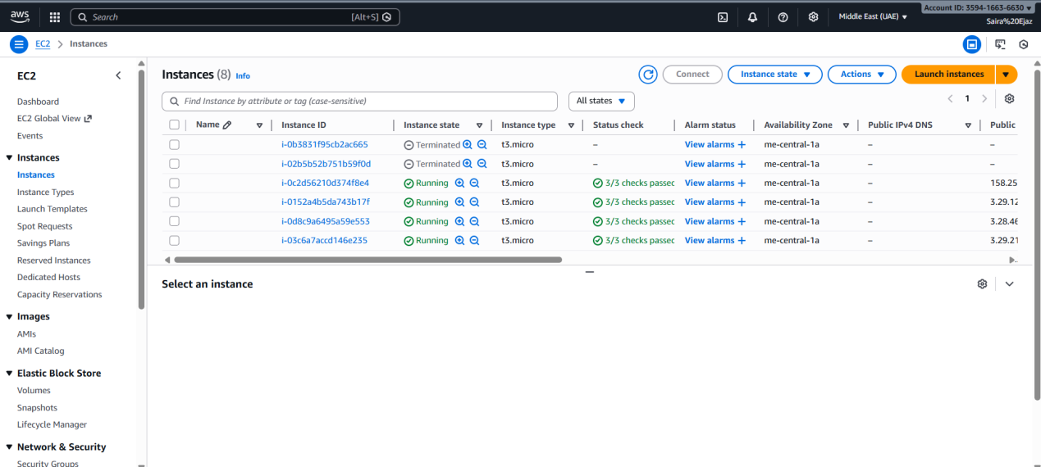
Part 5: Nginx Configuration & Testing (25 marks)
5.1 Update Nginx Backend Configuration (5 marks)
SSH into the Nginx server and update the configuration with actual backend IPs.
Deliverables:
Screenshot: assignment_part5_ssh_nginx.png (SSH session)
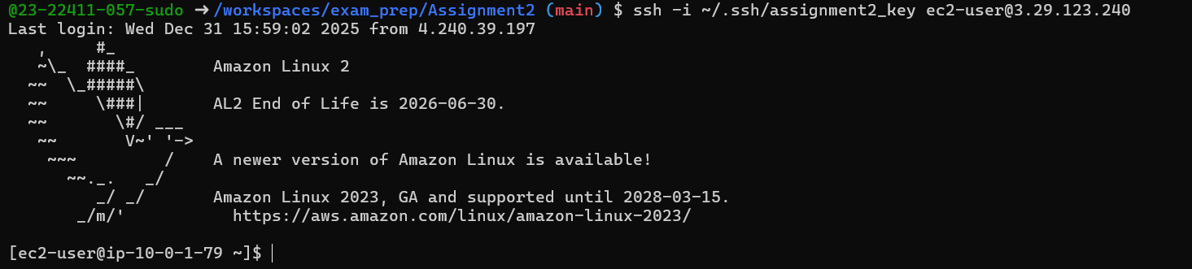
Screenshot: assignment_part5_nginx_conf_updated.png (updated upstream block)
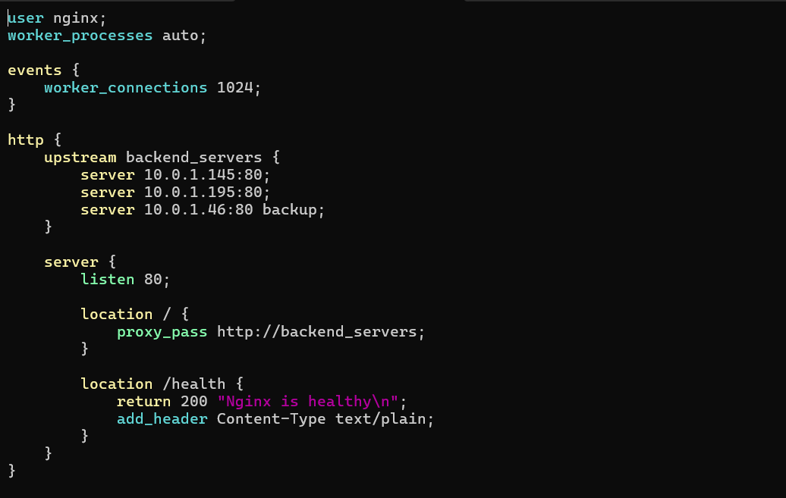
Screenshot: assignment_part5_nginx_test.png (nginx -t output)
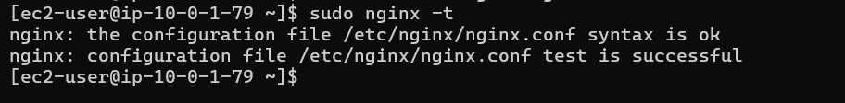
Screenshot: assignment_part5_nginx_restart.png (restart and status)
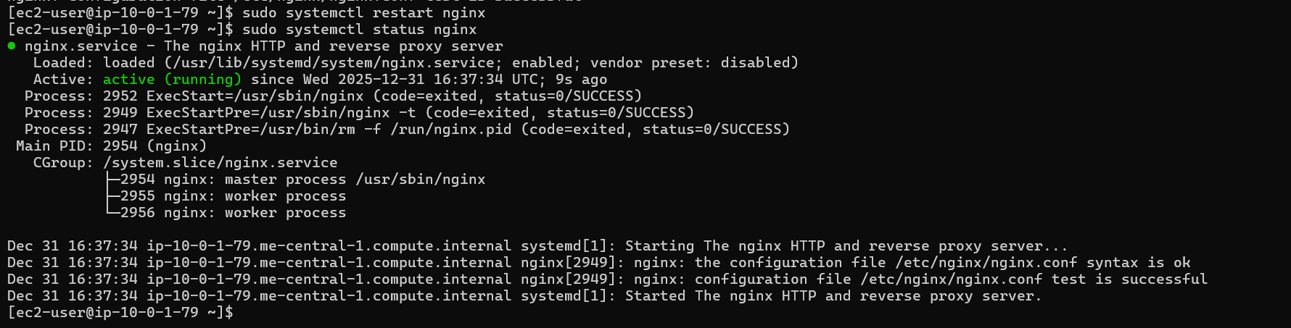
5.2 Test Load Balancing (5 marks)
Test that Nginx is properly load balancing between web-1 and web-2.
Deliverables:
Screenshot: assignment_part5_ssl_warning.png (browser security warning)
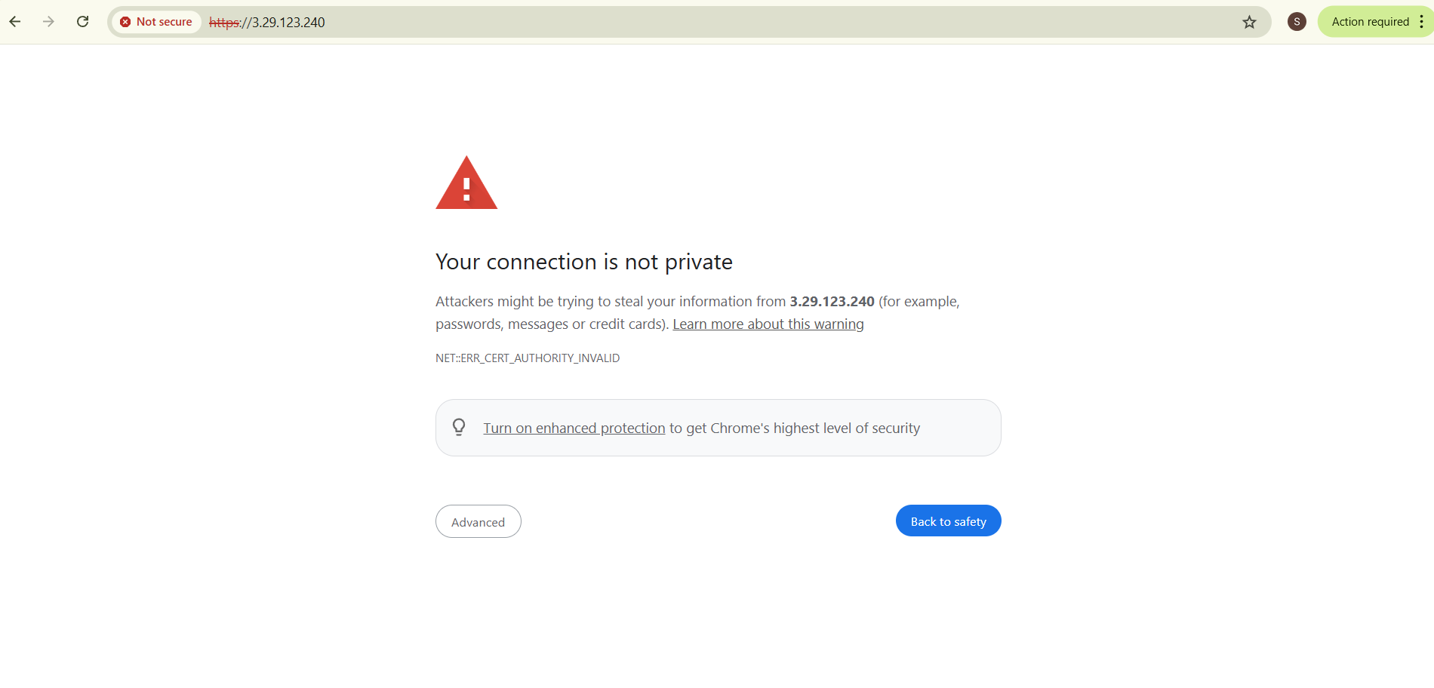
Screenshot: assignment_part5_web1_response.png (showing web-1 content)
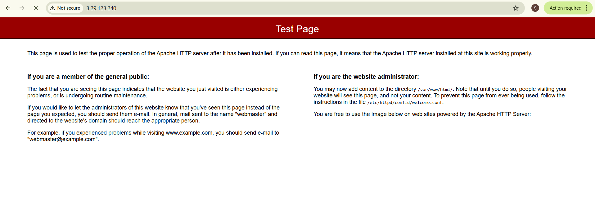
Screenshot: assignment_part5_web2_response. png (showing web-2 content)
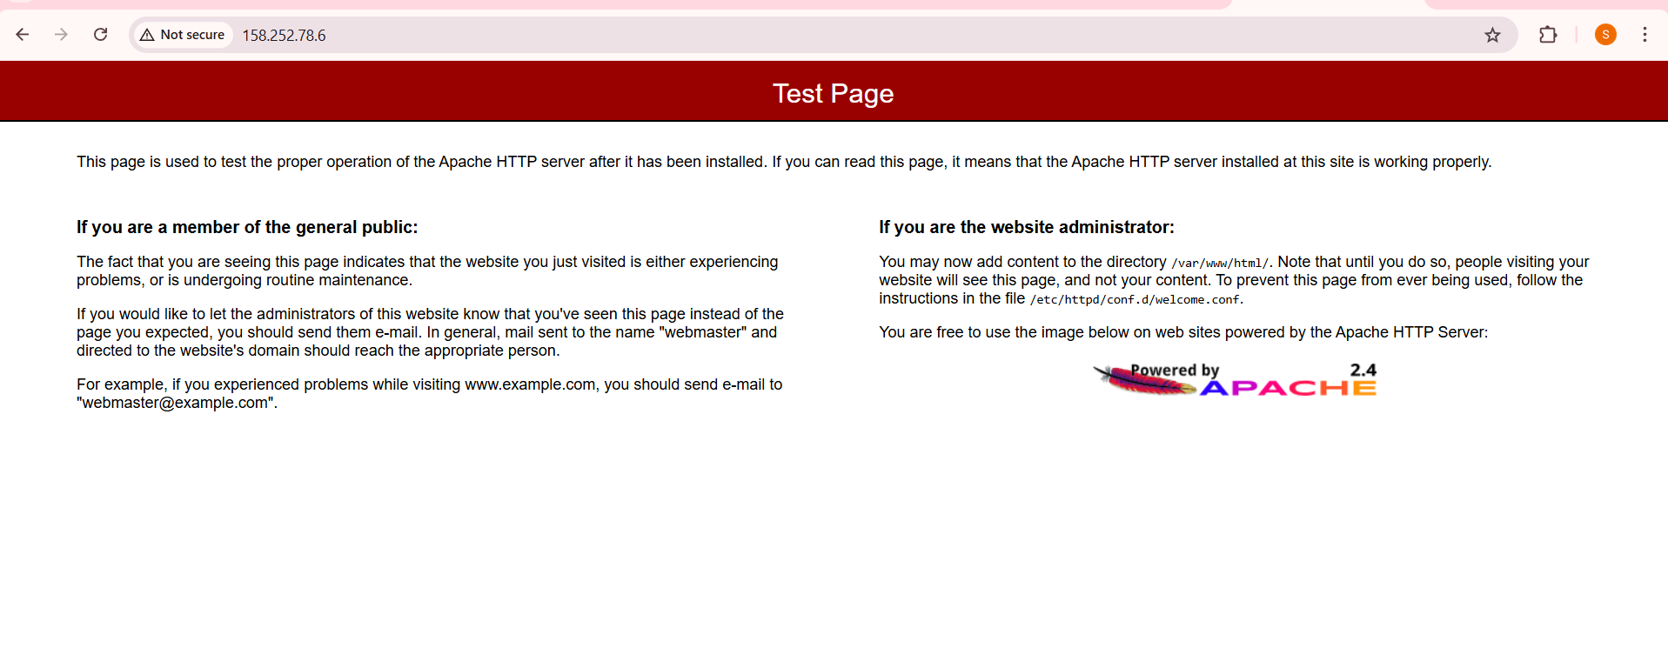
Screenshot: assignment_part5_load_balancing_demo.png (multiple reloads showing alternation)
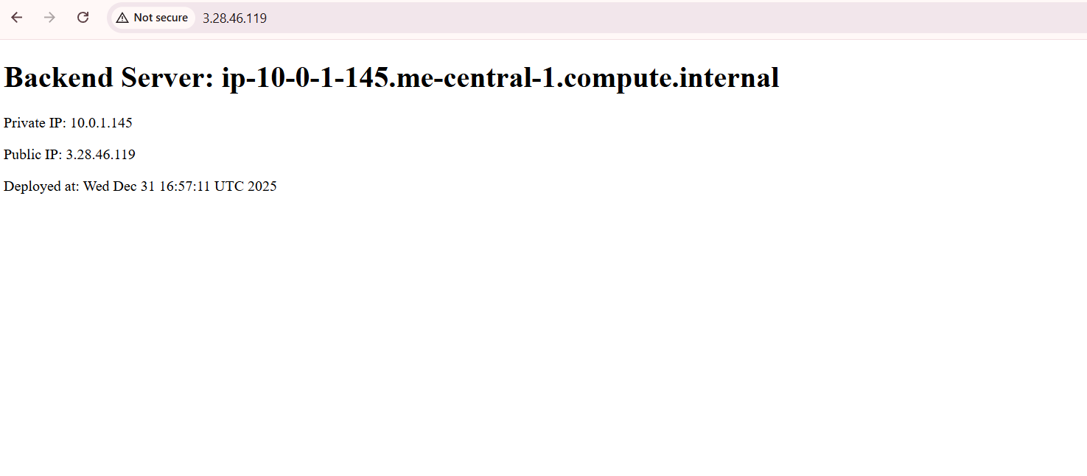
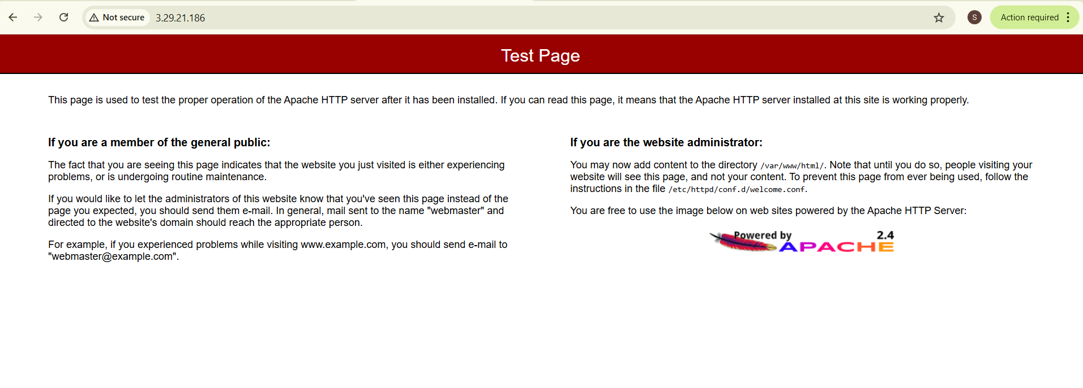

5.3 Test Cache Functionality (5 marks)
Verify that Nginx caching is working correctly.
Deliverables:
Screenshot: assignment_part5_cache_miss.png (first request - MISS)
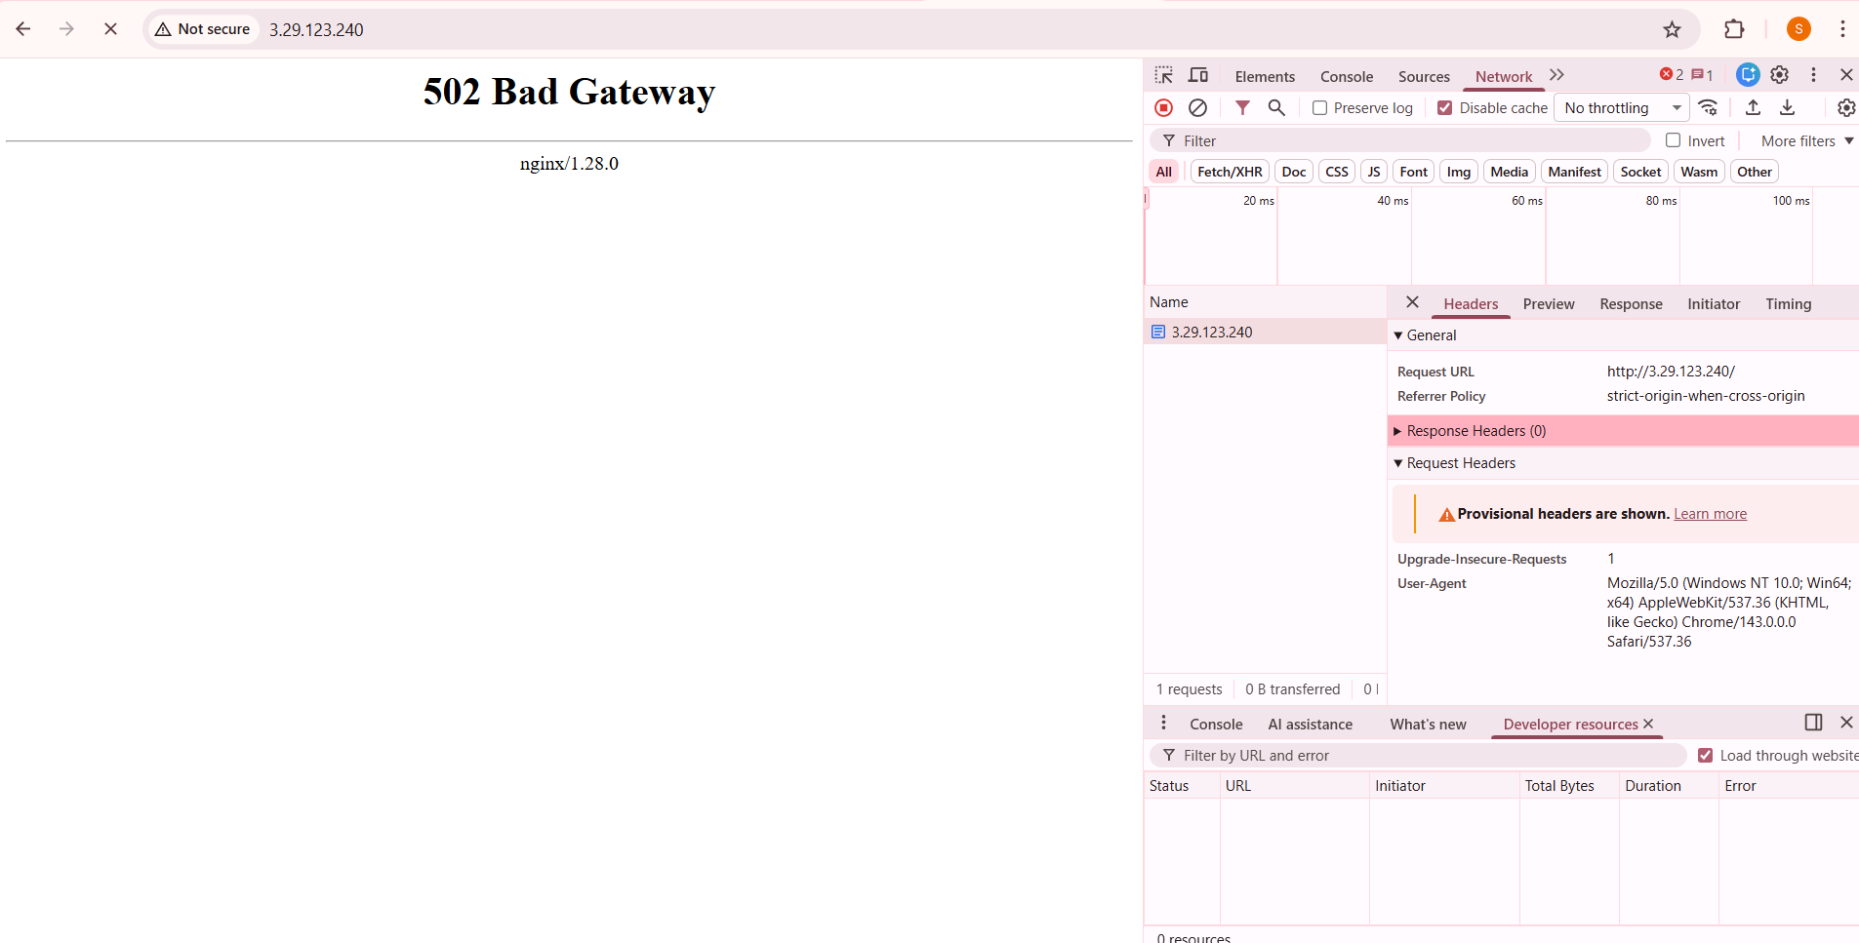
Screenshot: assignment_part5_cache_hit. png (second request - HIT)
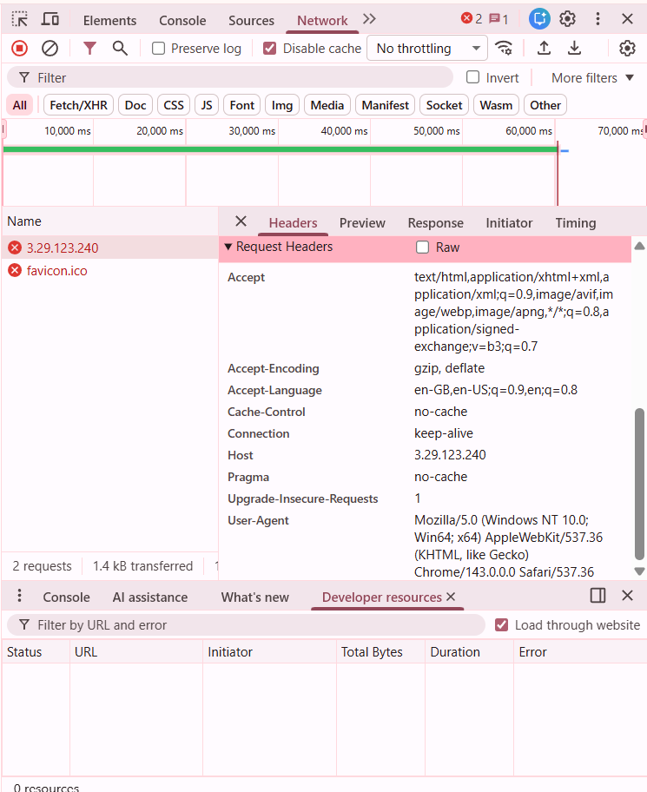
Screenshot: assignment_part5_cache_directory.png (cache folder contents)
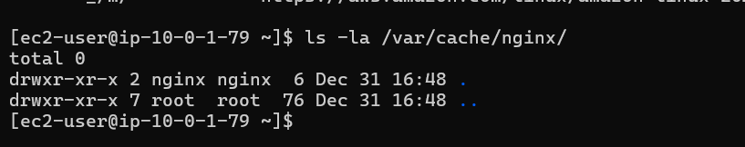
Screenshot: assignment_part5_access_log_cache.png (access log showing cache status)
5.4 Test High Availability (Backup Server) (5 marks)
Test the backup server functionality by simulating primary server failure.
Deliverables:
Screenshot: assignment_part5_web1_stopped.png (web-1 Apache stopped)
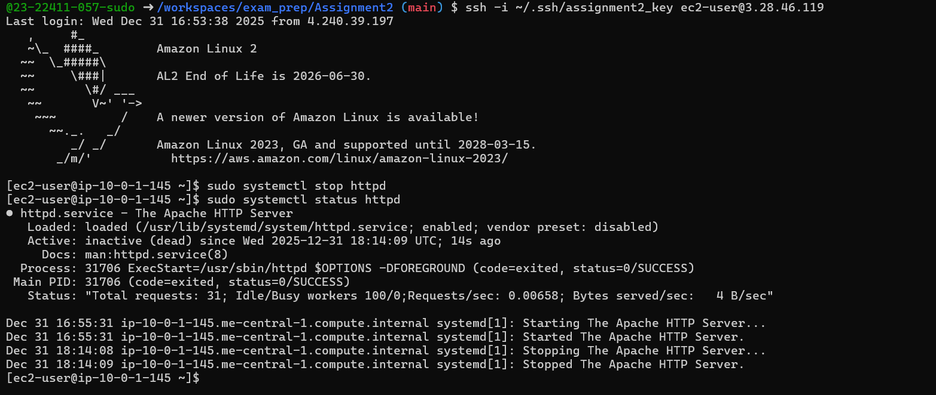
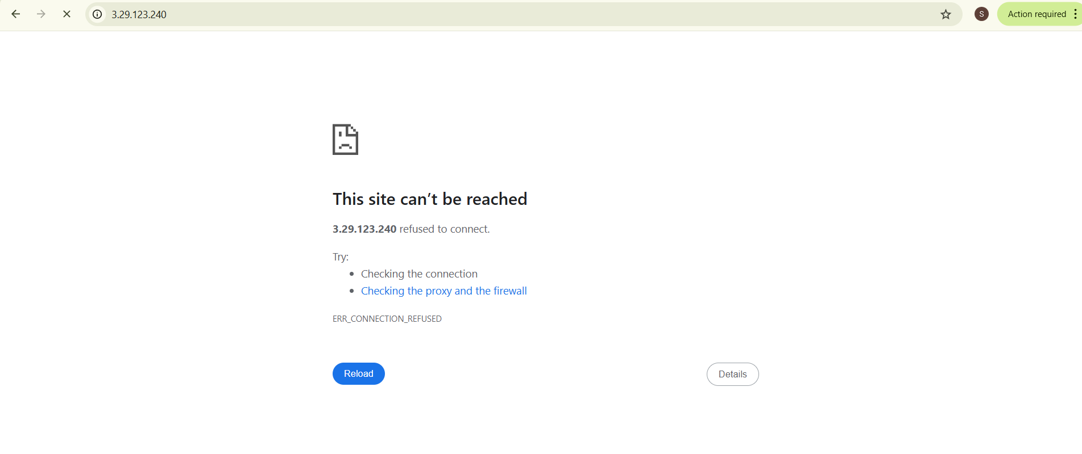
Screenshot: assignment_part5_web2_stopped.png (web-2 Apache stopped)
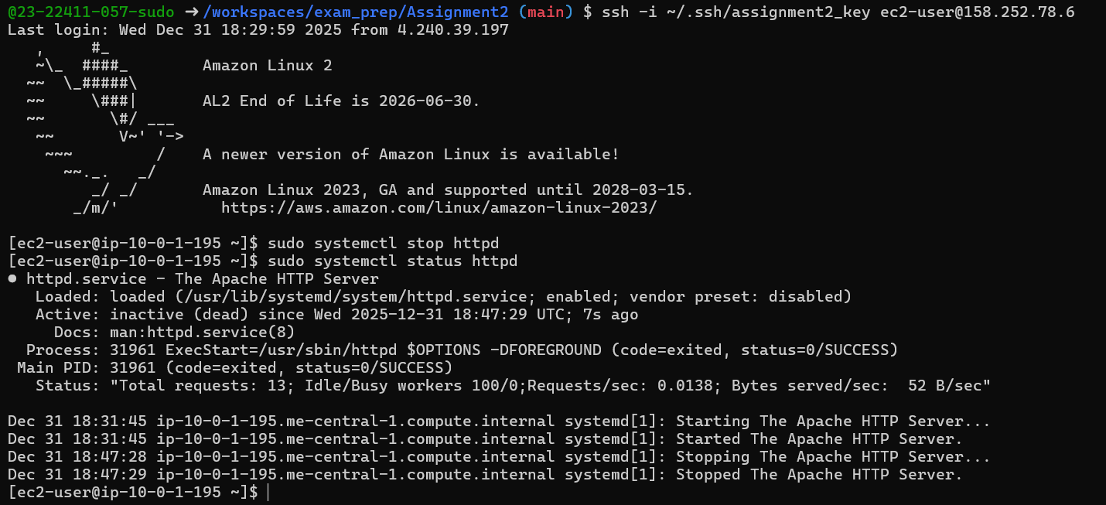
Screenshot: assignment_part5_backup_activated.png (web-3 serving traffic)
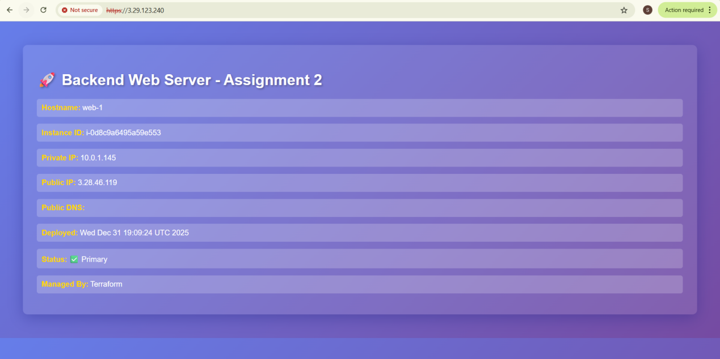
Screenshot: assignment_part5_nginx_error_log.png (error log showing backend failures)
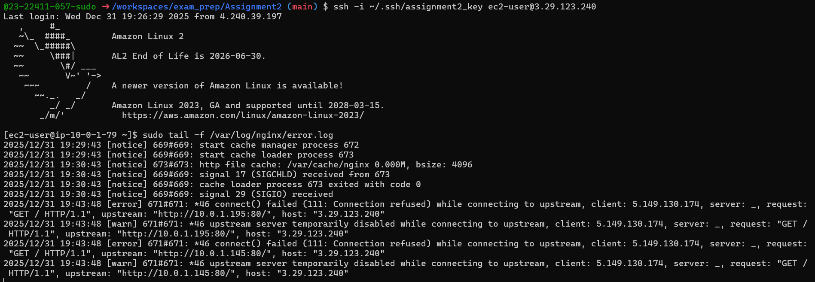
Screenshot: assignment_part5_services_restored.png (all services back online)
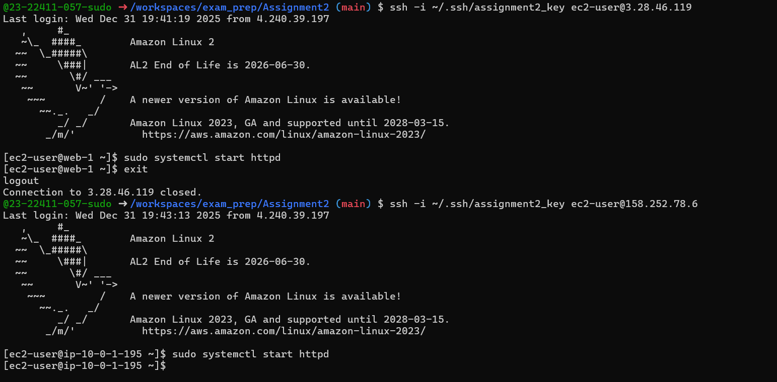
5.5 Security & Performance Analysis (5 marks)
Analyze the security headers and performance of your Nginx setup.
Deliverables:
Screenshot: assignment_part5_ssl_certificate.png (certificate details)
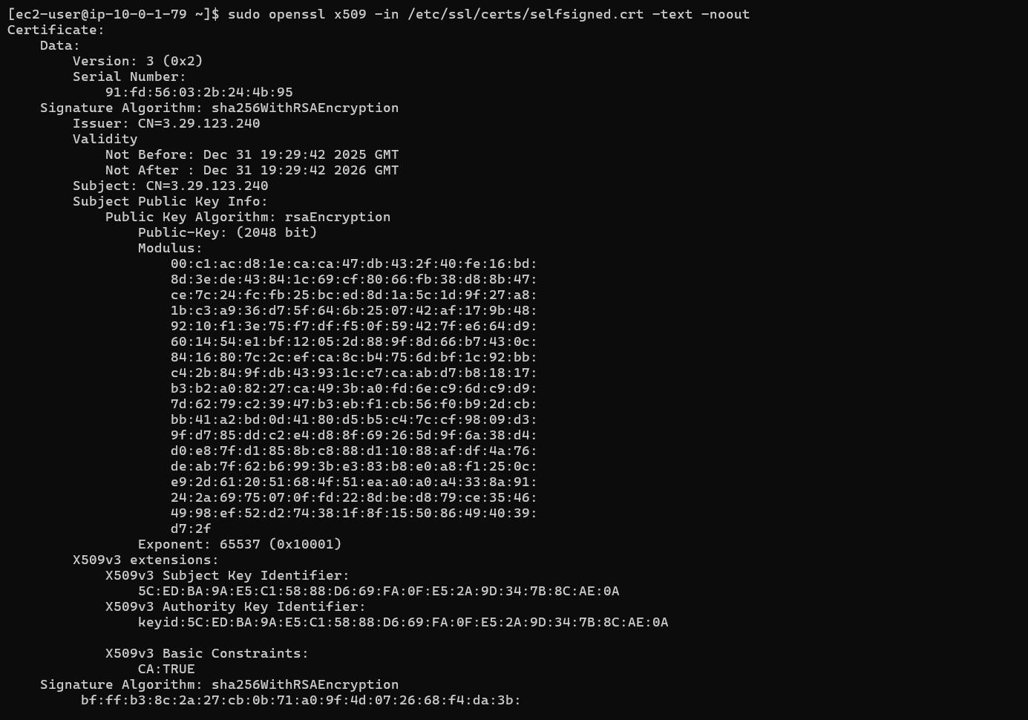
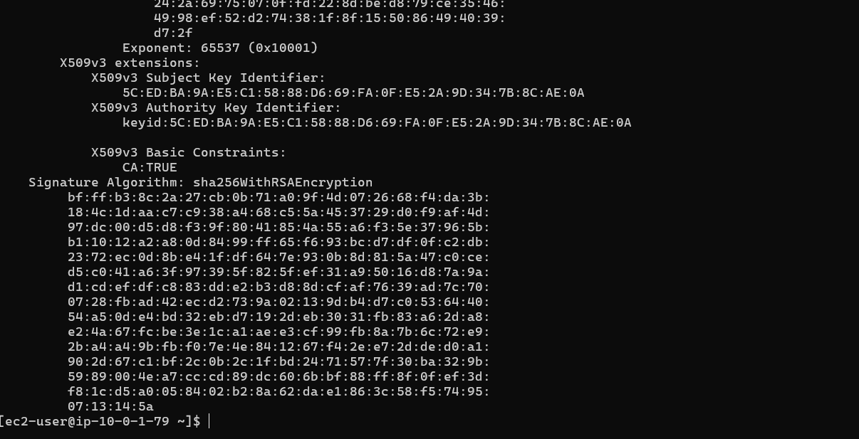
Screenshot: assignment_part5_security_headers. png (response headers showing security headers)
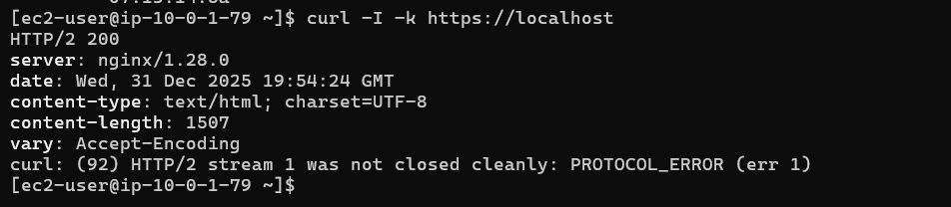
Screenshot: assignment_part5_http_redirect.png (301 redirect test)
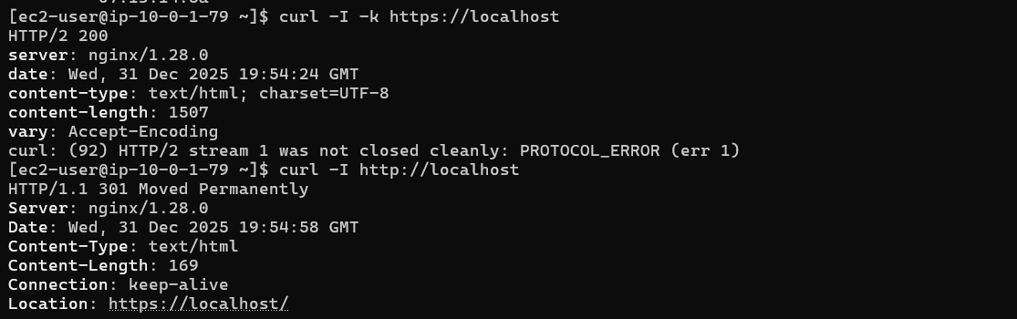
Screenshot: assignment_part5_error_log_analysis.png (error log review)
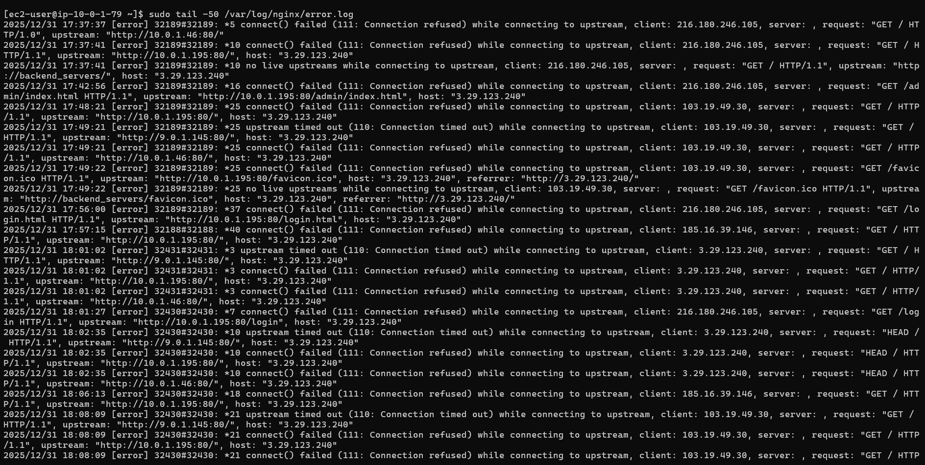
Screenshot: assignment_part5_access_log_analysis.png (access log patterns)
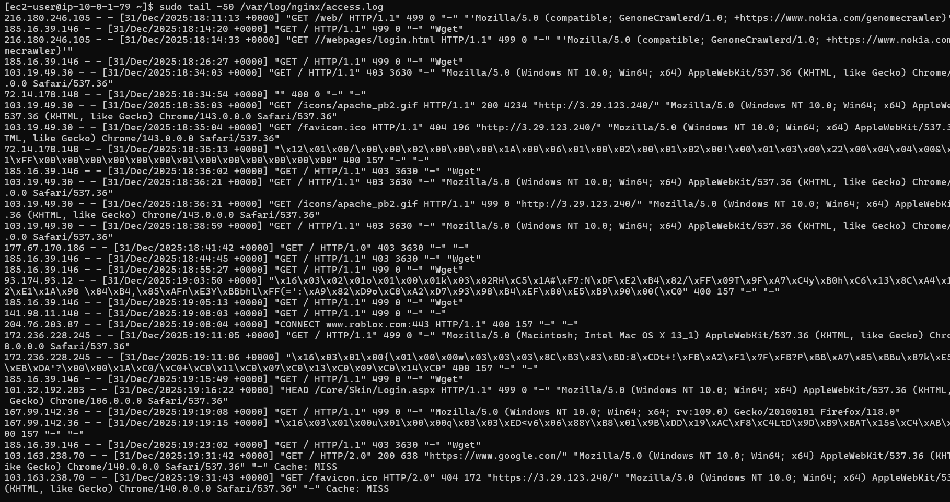

Bonus Tasks (10 marks extra credit)
Bonus 1: Custom Error Pages (3 marks)
Create custom error pages for Nginx (404, 502, 503).
Deliverables:
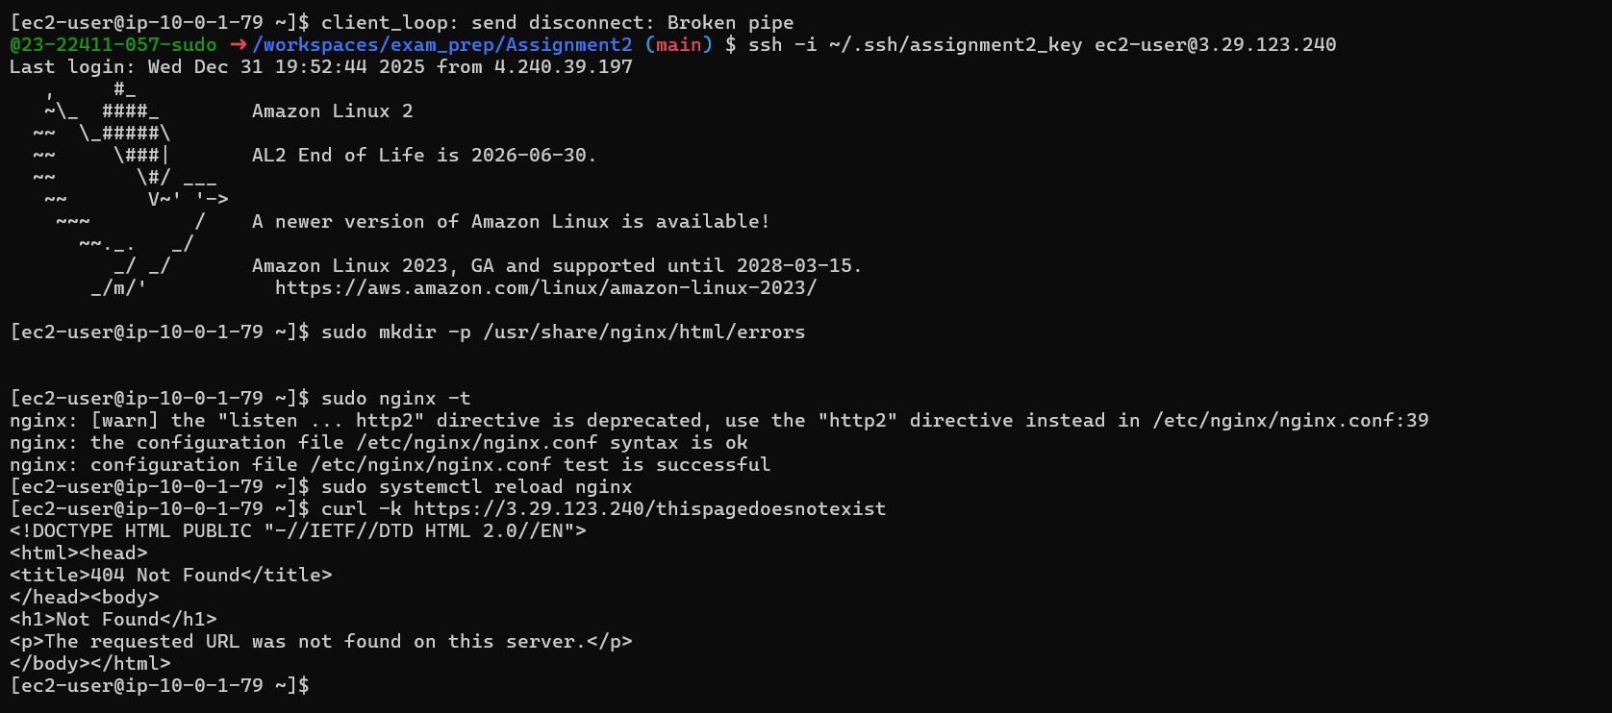
Screenshot: bonus1_custom_404.png
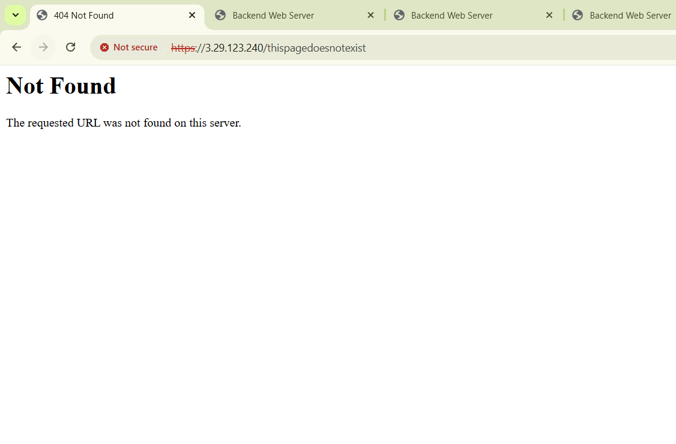
Screenshot: bonus1_custom_502.png
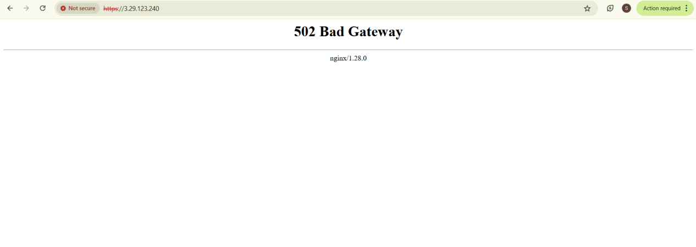
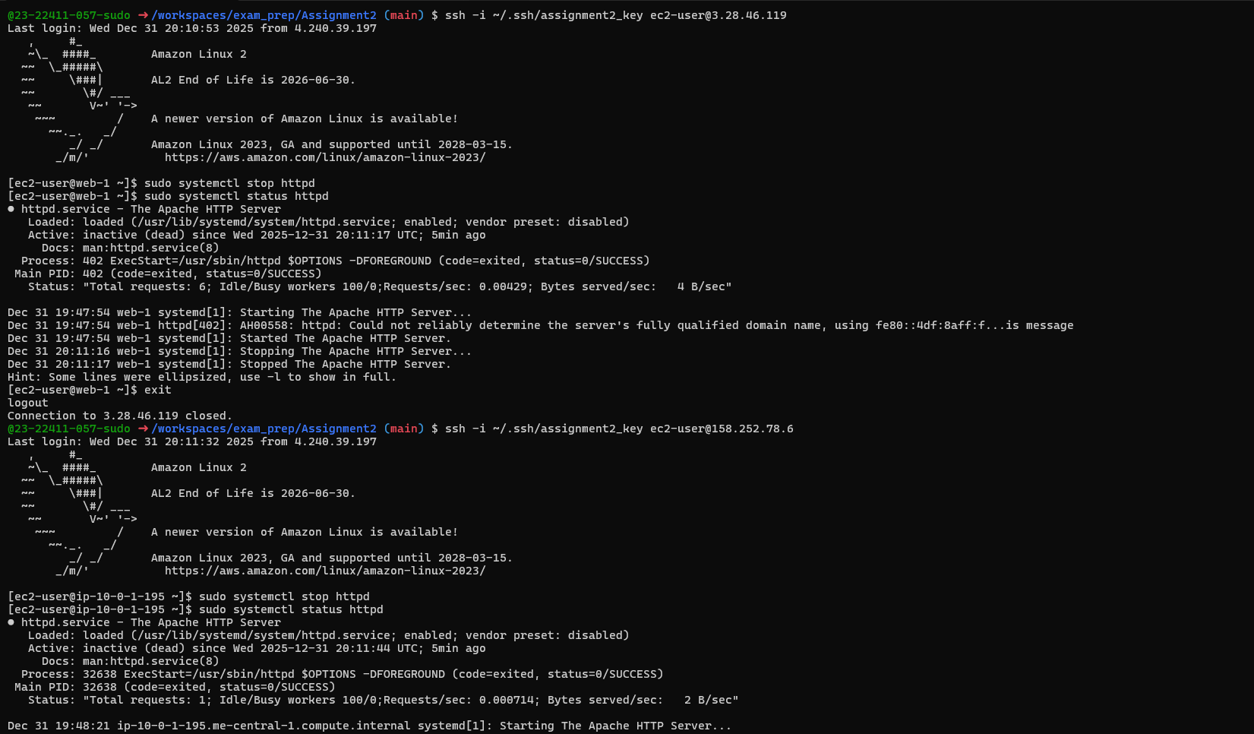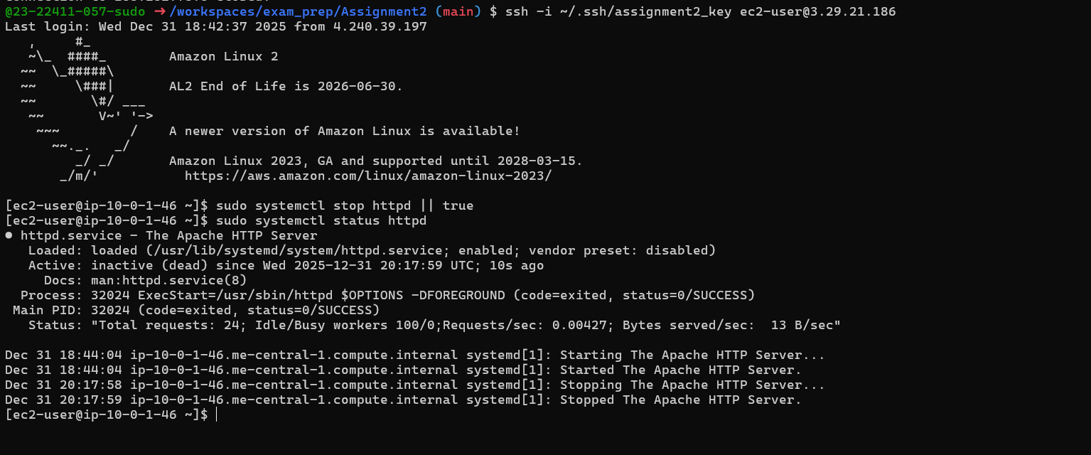
Bonus 2: Implement Rate Limiting (3 marks)
Add rate limiting to prevent abuse.
Configuration Example:
Deliverables:
Screenshot: bonus2_rate_limit_config.png
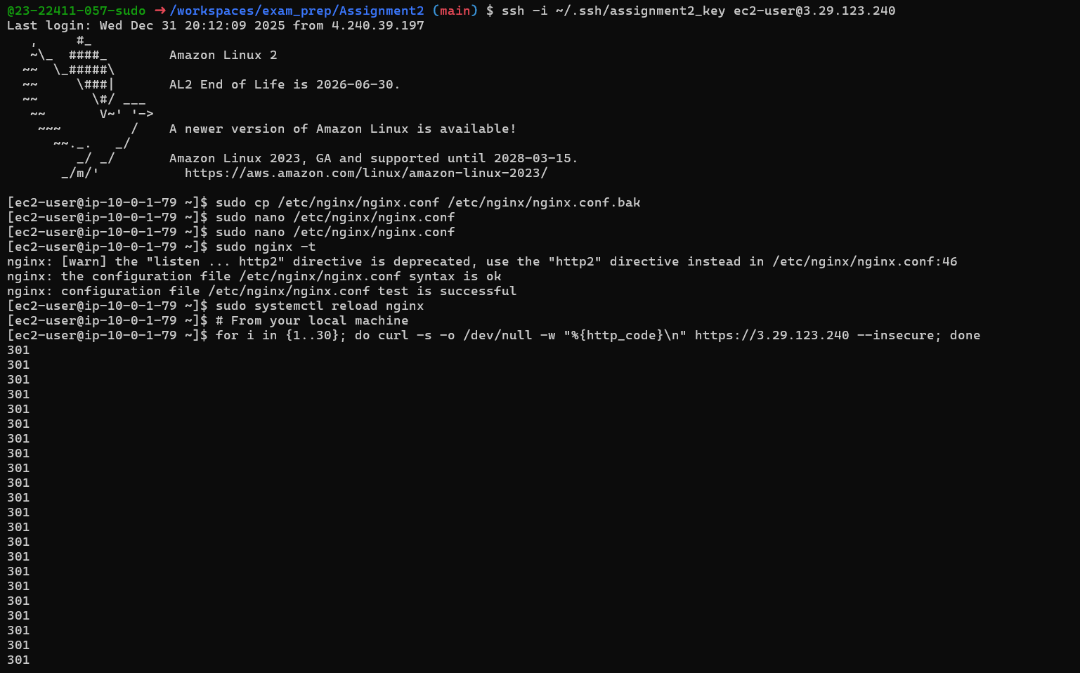
Screenshot: bonus2_rate_limit_test.png
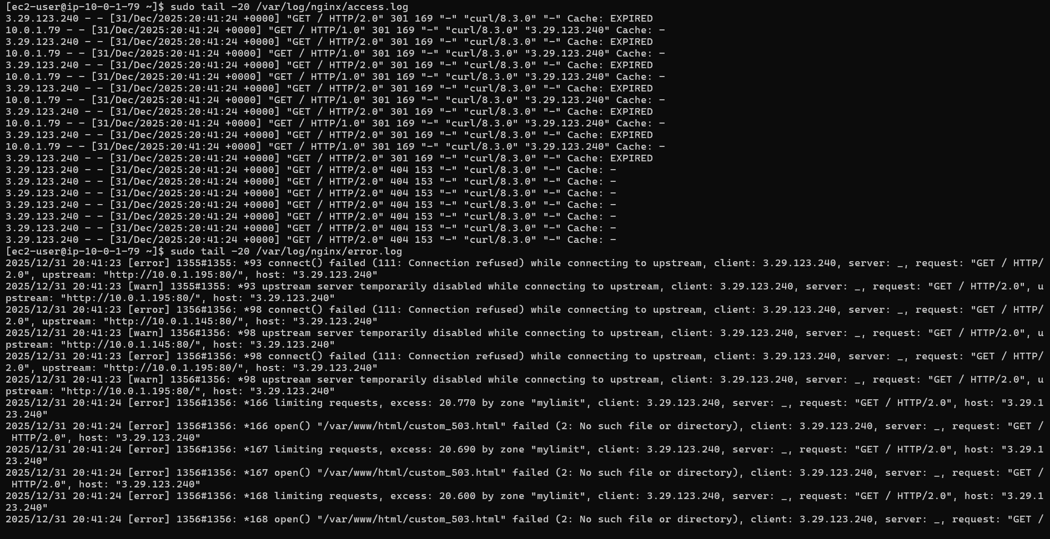
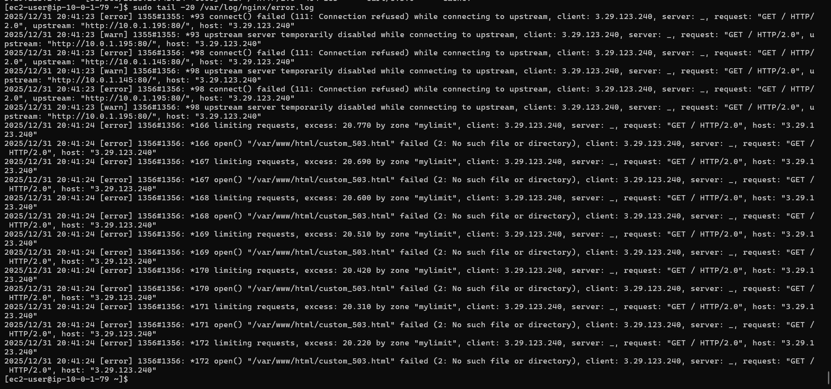

Bonus 3: Health Check Automation (4 marks)
Deliverables:
Health check script
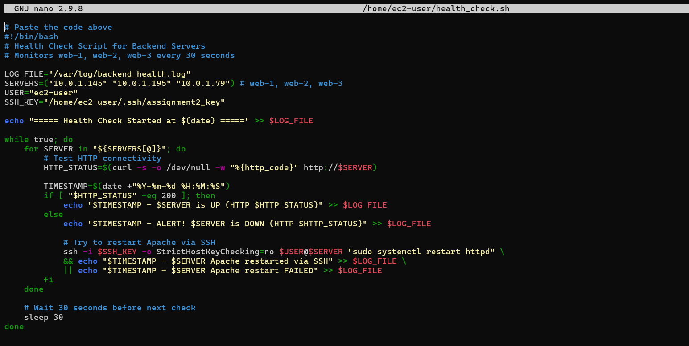
Screenshot: bonus3_health_check_script.png
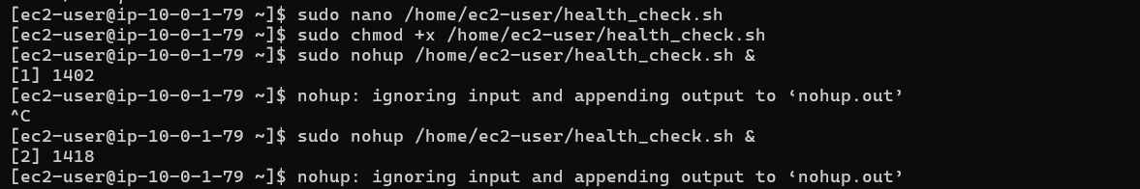
Screenshot: bonus3_health_log.png
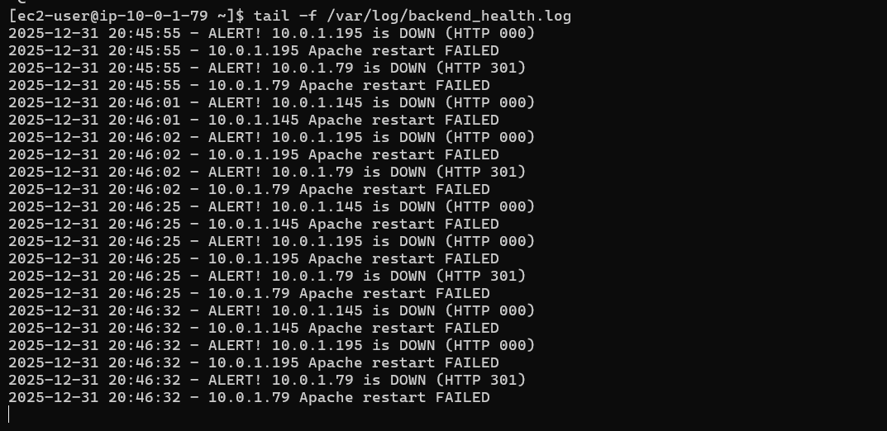
Part 6: Documentation & Cleanup (10 marks)
6.1 README Documentation (5 marks)
Screenshot: assignment_part6_readme.png (README.md content)
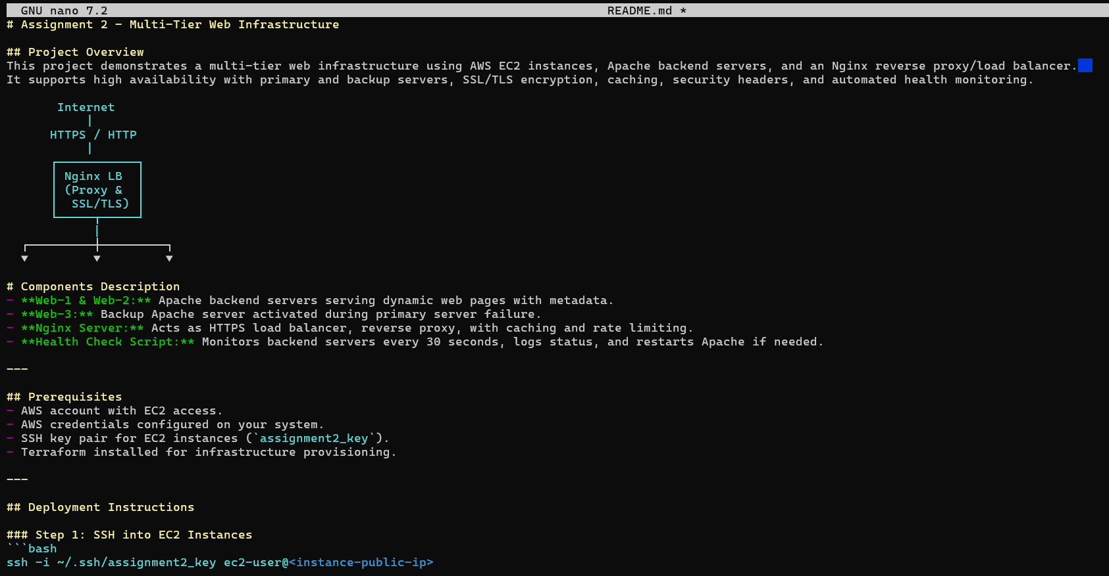
6.2 Infrastructure Cleanup (5 marks)
Properly destroy all resources and verify cleanup.
Deliverables:
Screenshot: assignment_part6_terraform_destroy_prompt.png
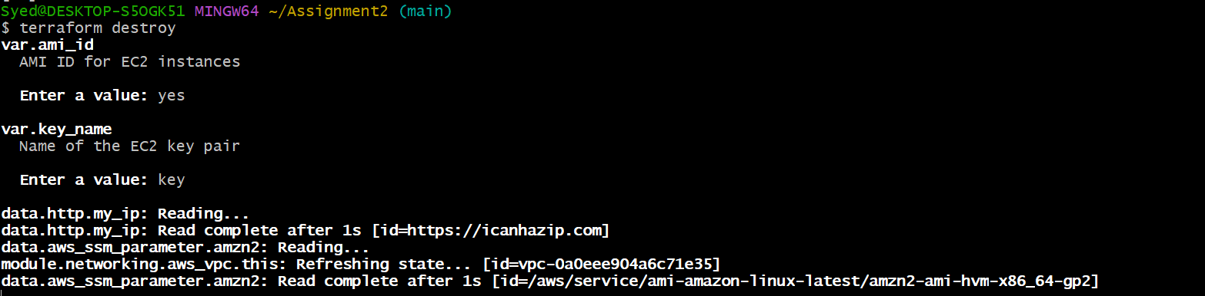
Screenshot: assignment_part6_terraform_destroy_complete.png
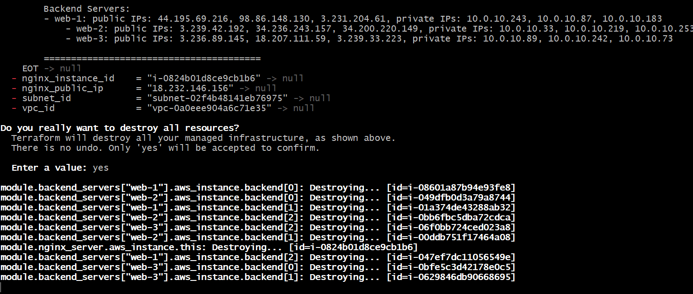
Screenshot: assignment_part6_aws_instances_destroyed.png (AWS Console showing no instances)
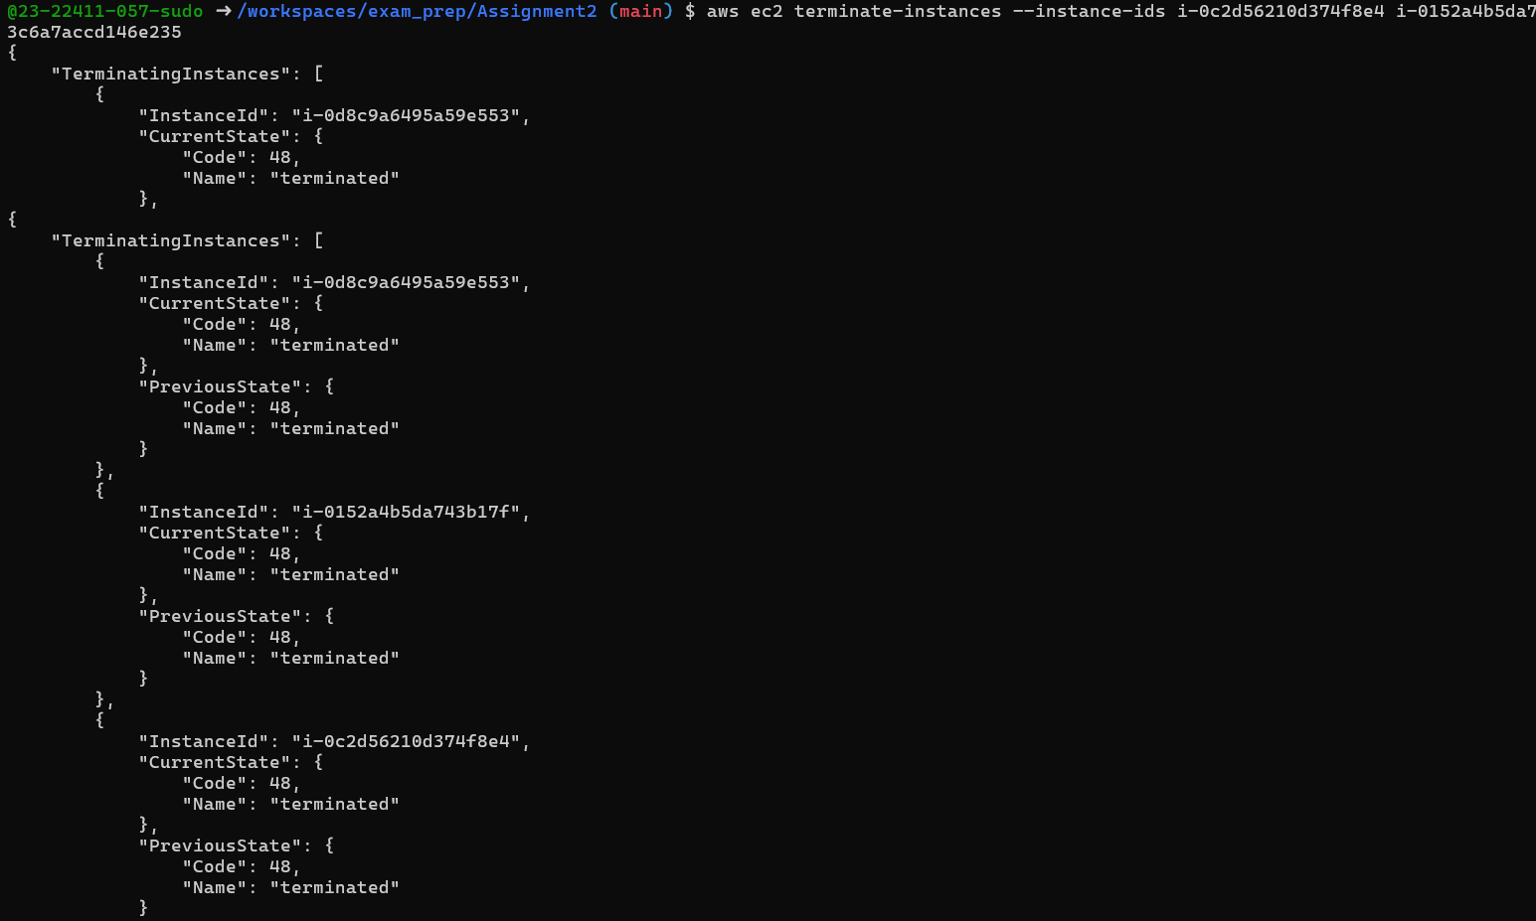
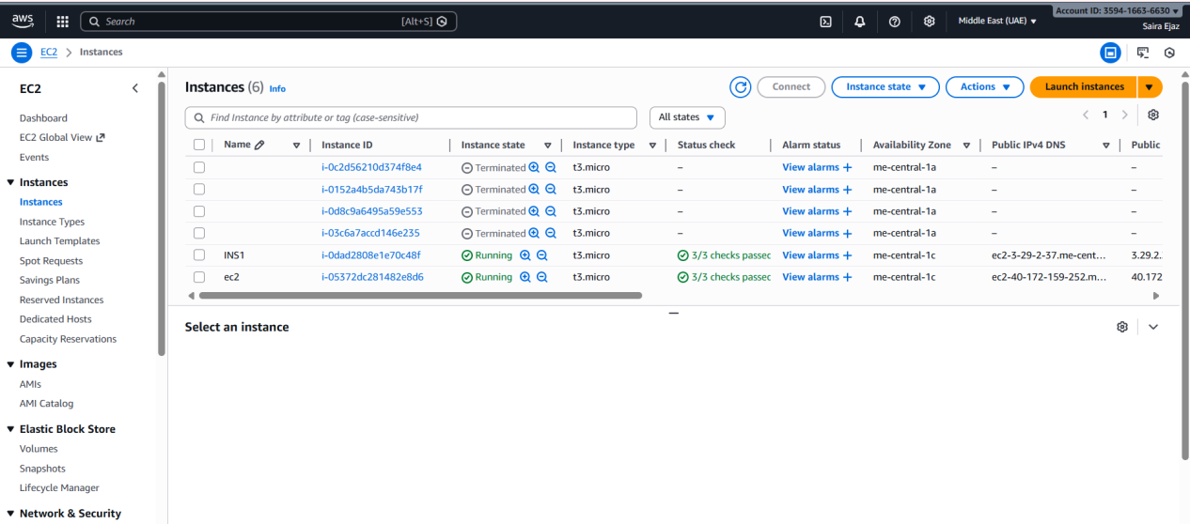
Screenshot: assignment_part6_empty_state. png (empty terraform.tfstate)
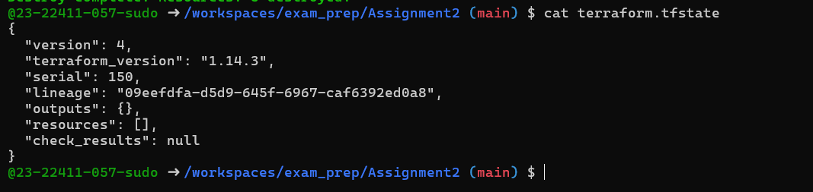
- Github Submission:
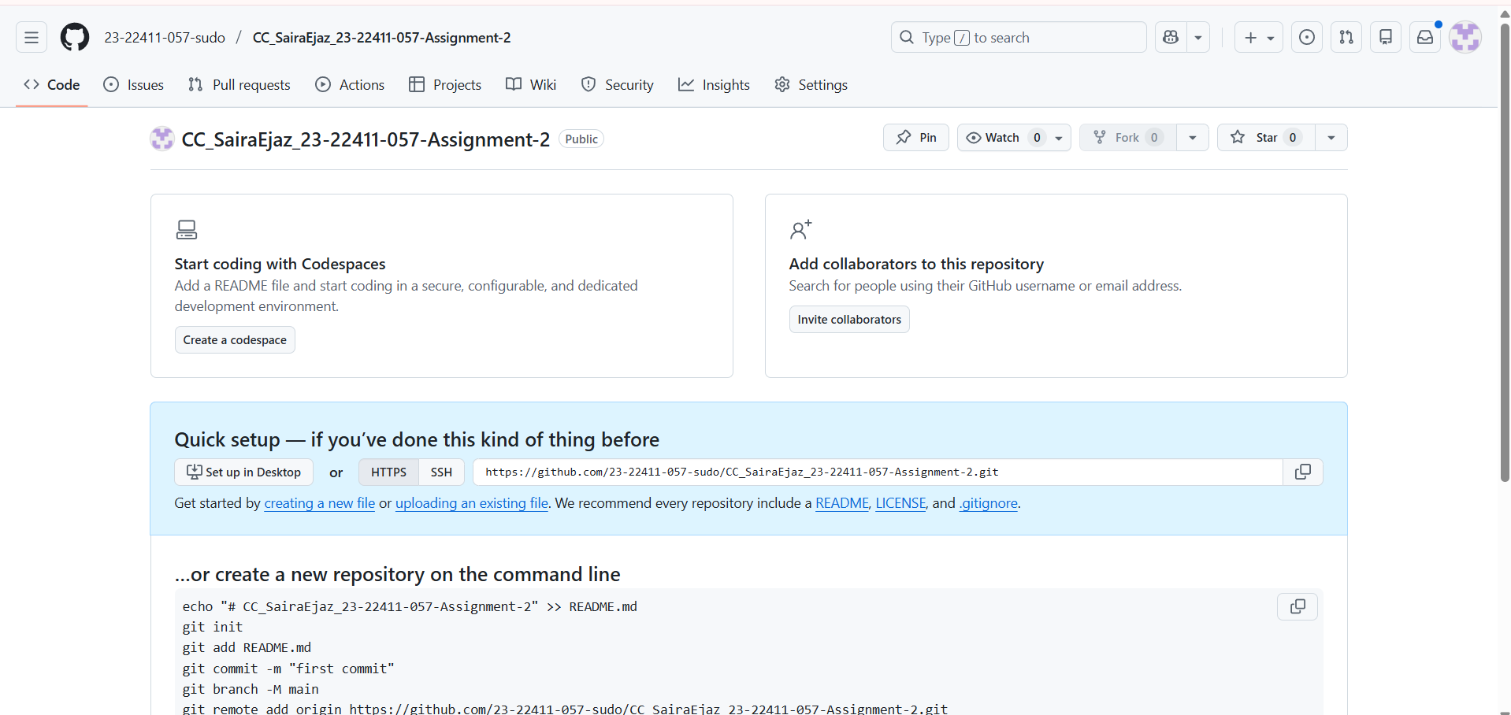
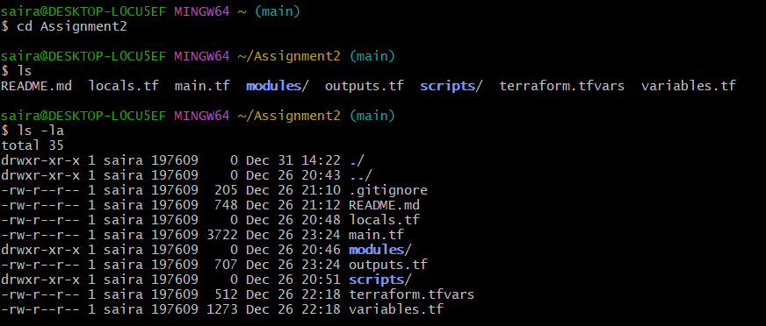
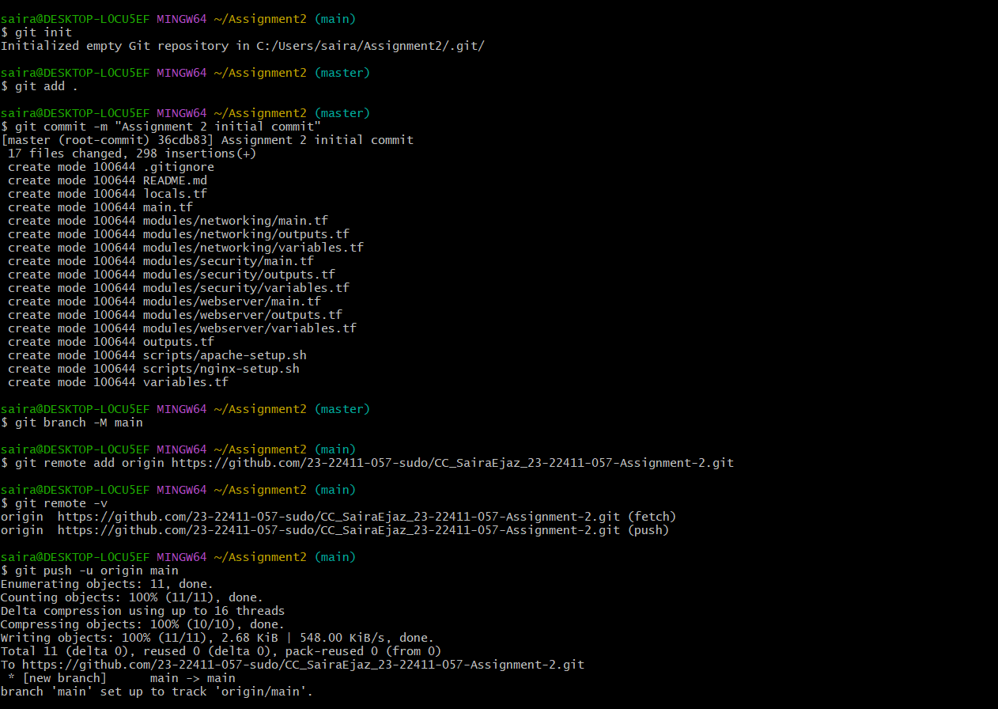
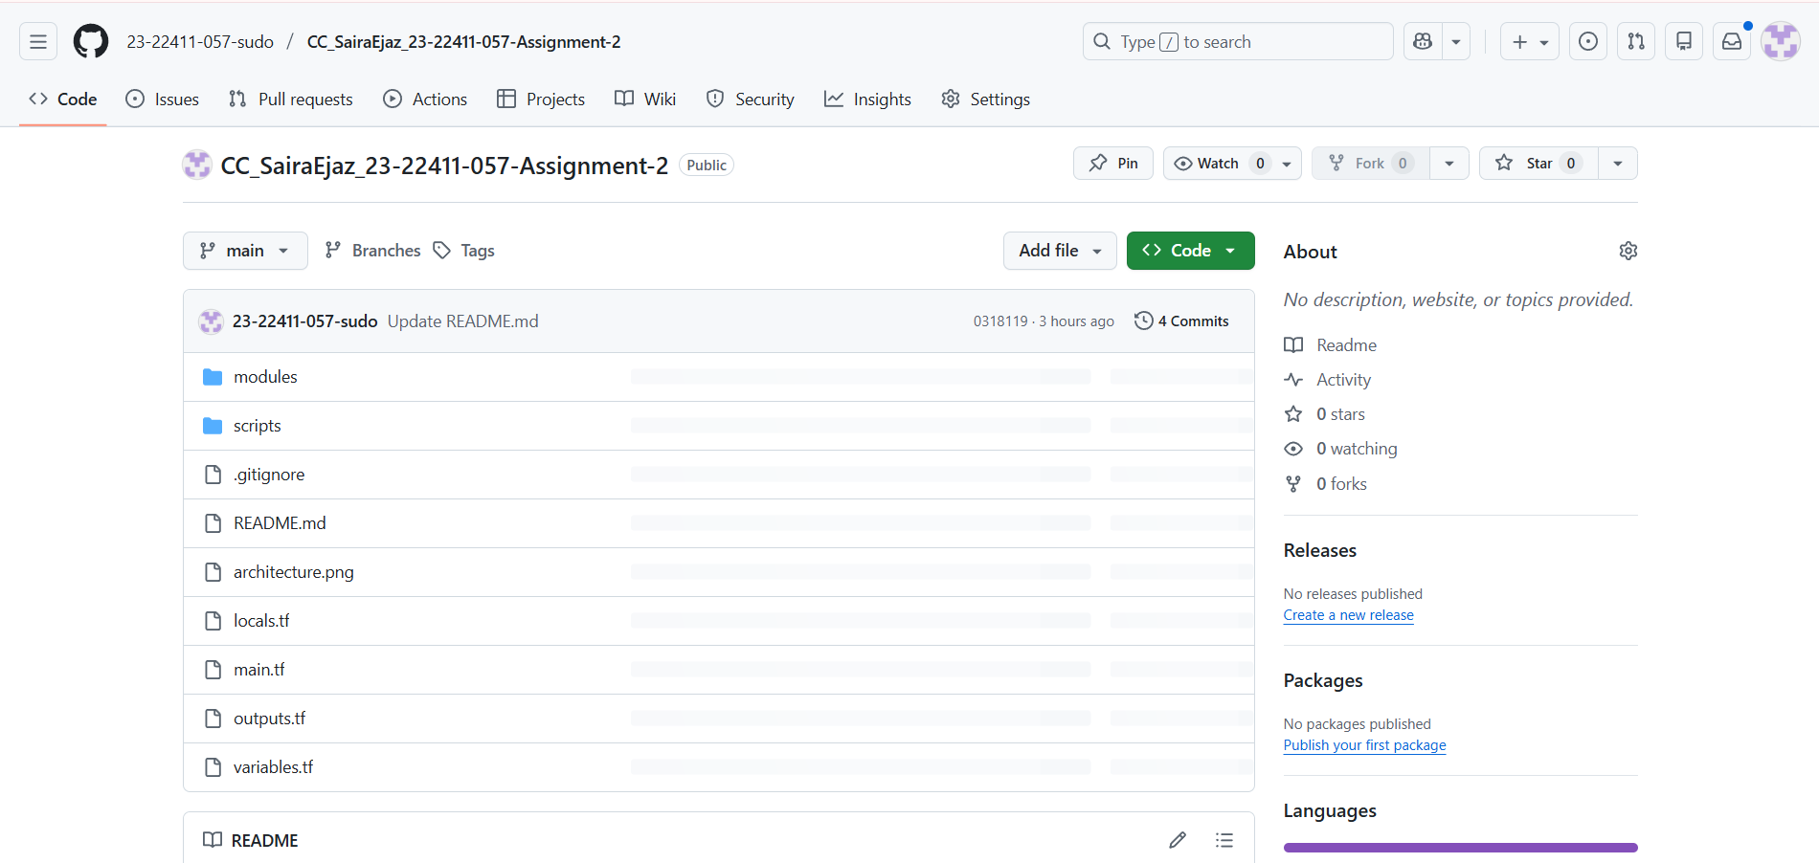
Repository Link:
https://github.com/23-22411-057-sudo/CC_SairaEjaz_23-22411-057-Assignment-2

Key Achievements:

It involves designing and deploying a multi-tier web application infrastructure on AWS using Terraform. It included creating modular components for networking, security, and webservers, implementing load balancing with Nginx, and ensuring proper routing and access control within the VPC. The project also covered testing, monitoring, and resource cleanup, providing practical experience in cloud infrastructure management.

Challenges & Solutions

Problems Encountered:

Terraform attribute errors

EC2 termination issues

Load balancing verification

Solutions:

Corrected module outputs

Cleared state lock files

Used browser tools and logs to verify load balancing

Conclusion
this project provided hands-on experience in designing, deploying, and managing a multi-tier web infrastructure on AWS using Terraform. It strengthened understanding of modular infrastructure design, networking, security groups, and automated deployment processes. Through implementation and testing, skills in load balancing, caching, and high availability were enhanced. The project also highlighted the importance of proper documentation, resource cleanup, and troubleshooting in real-world cloud environments, preparing for future cloud and DevOps tasks.

